**Assignment on Typecasting**

**Submitted by: Akash Sharad Badgujar**

1. **char to char**

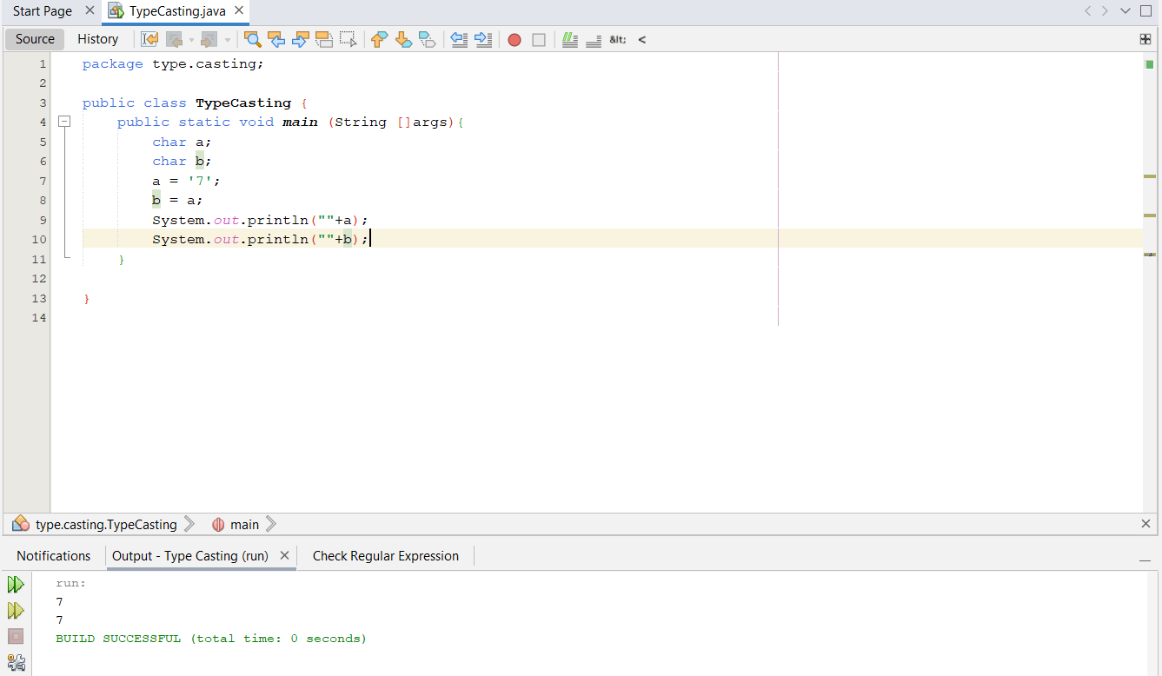

**Typecasting not required**

1. **char to byte**

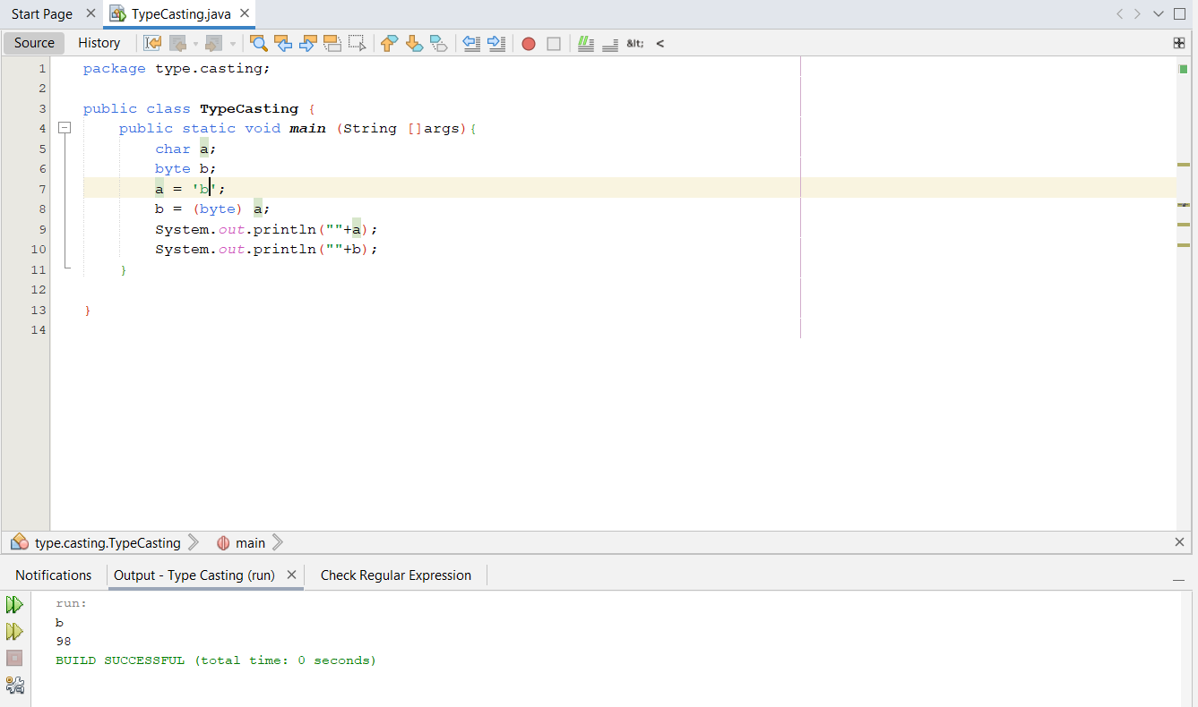

**Explicit typecasting required**

1. **char to short**

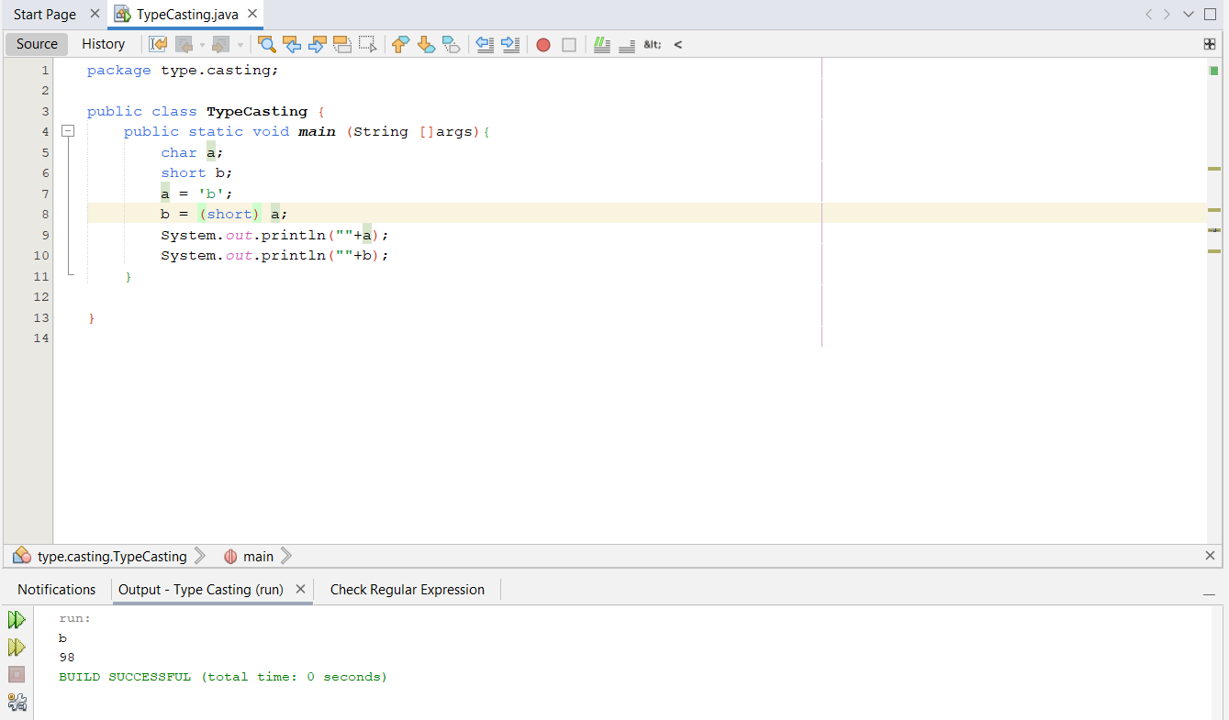

**Explicit typecasting required**

1. **char to int**

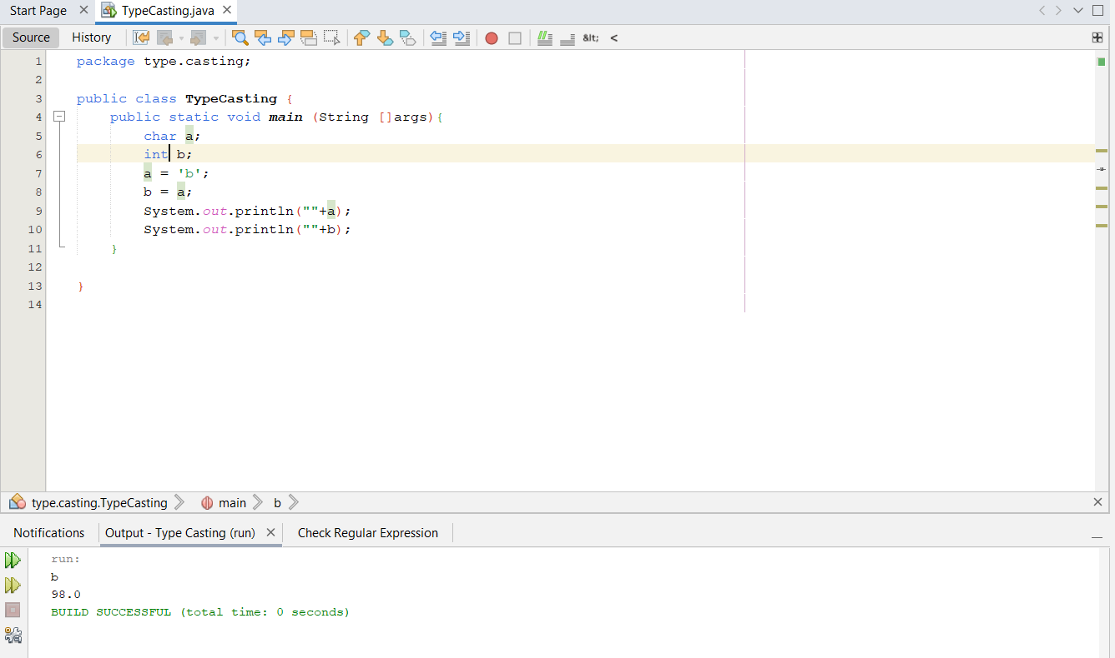

**Implicit typecasting required**

1. **char to long**

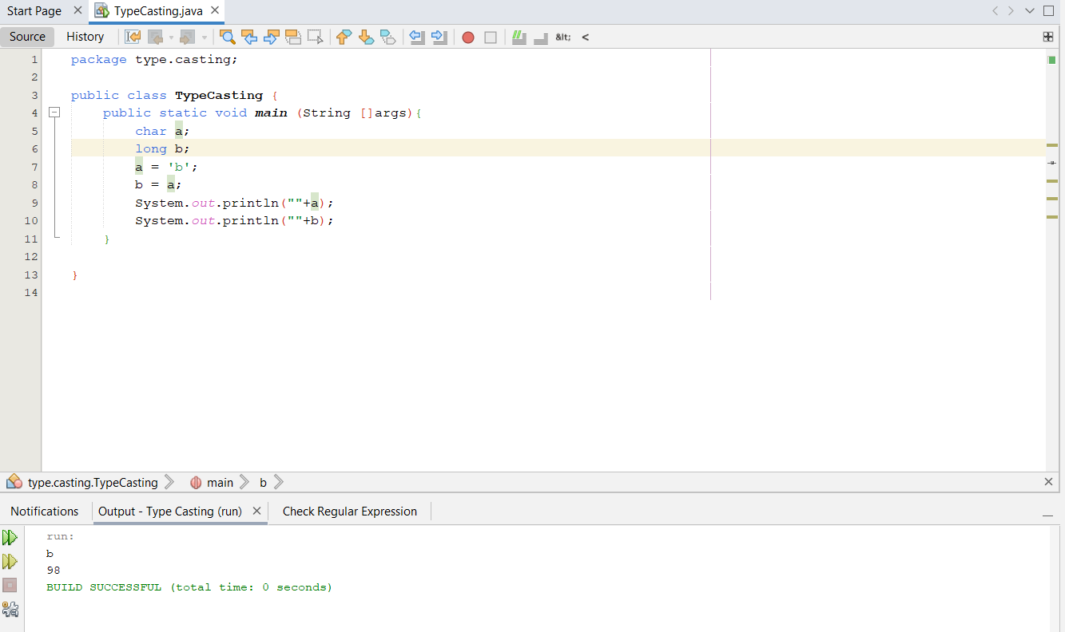

**Implicit typecasting required**

1. **char to float**

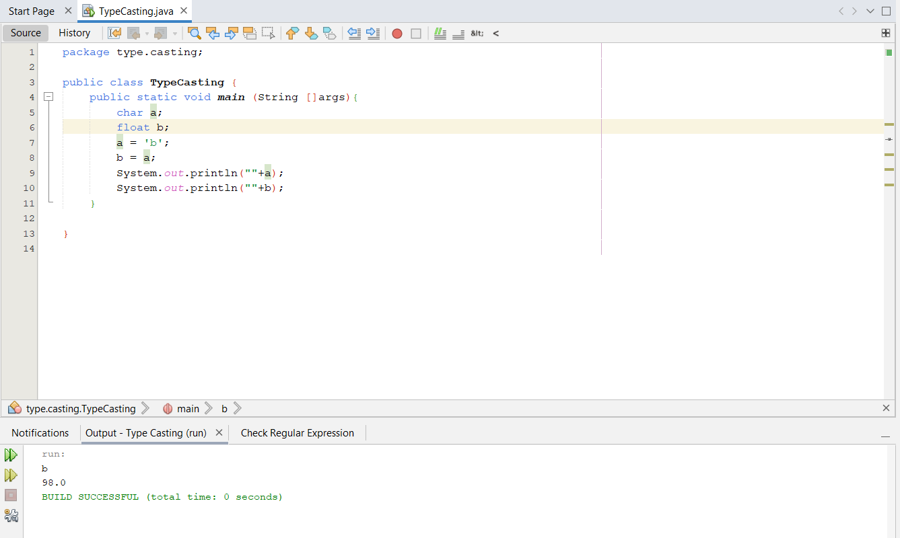

**Implicit typecasting required**

1. **char to double**

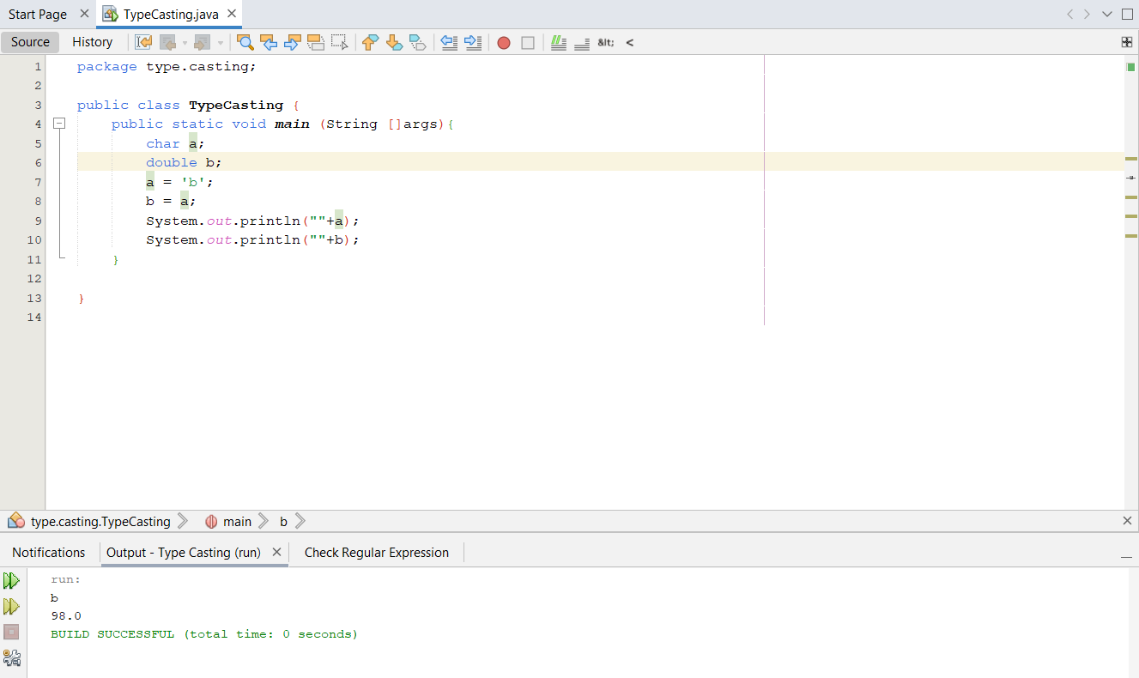

**Implicit typecasting required**

1. **char to Boolean**

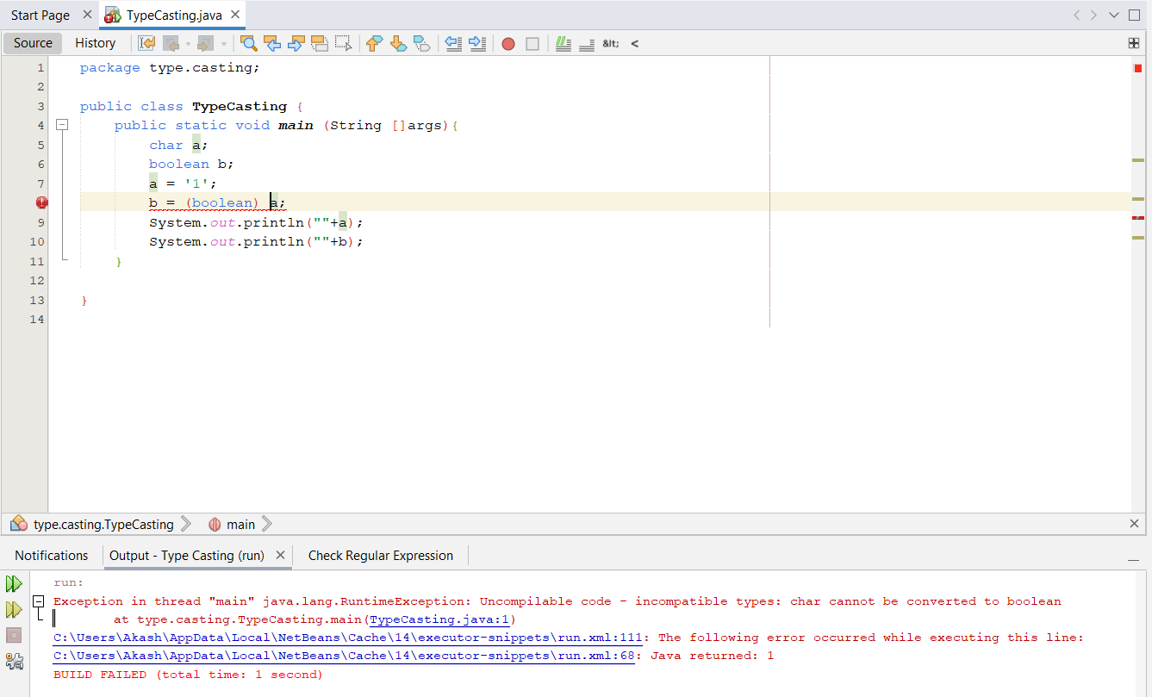

**Typecasting cannot be done**

1. **byte to char**

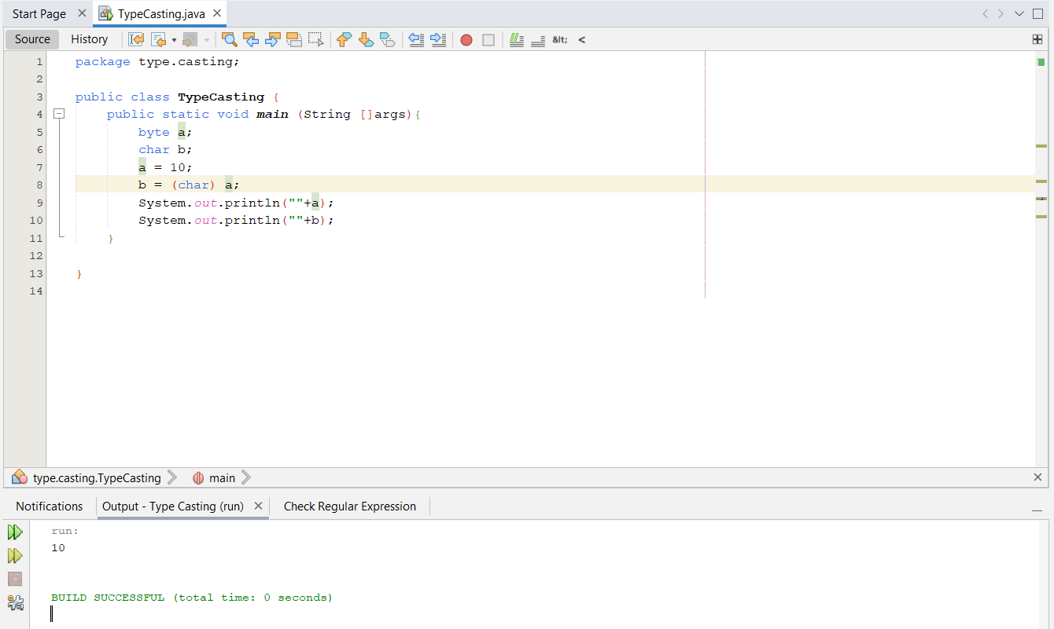

**Explicit typecasting Required**

1. **byte to byte**



**Typecasting not required**

1. **byte to short**

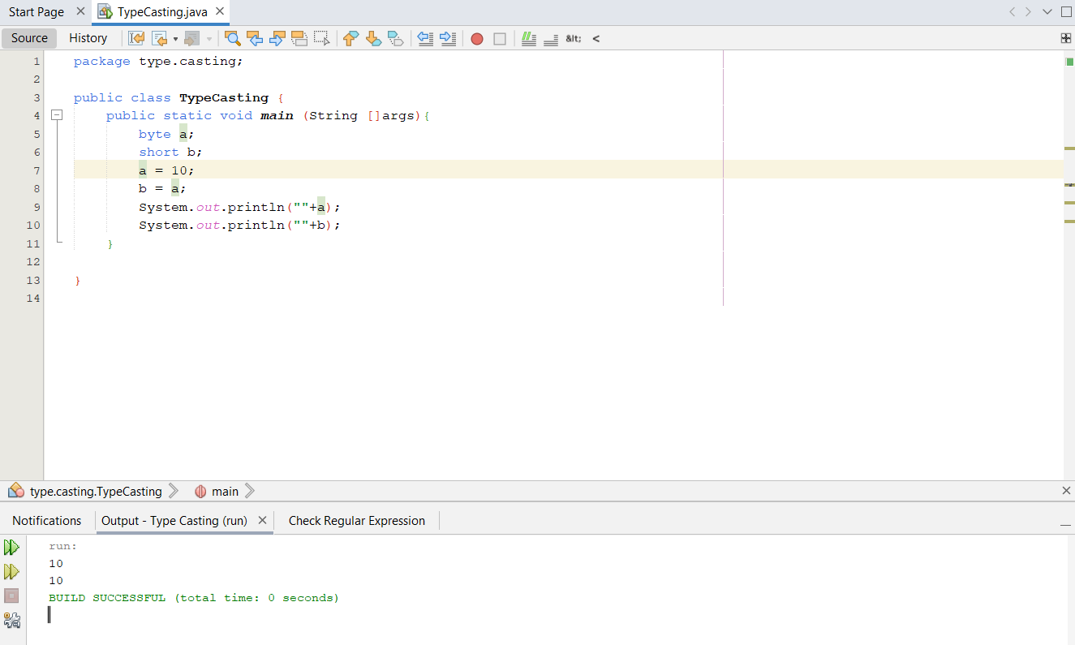

**Implicit typecasting required**

1. **byte to int**

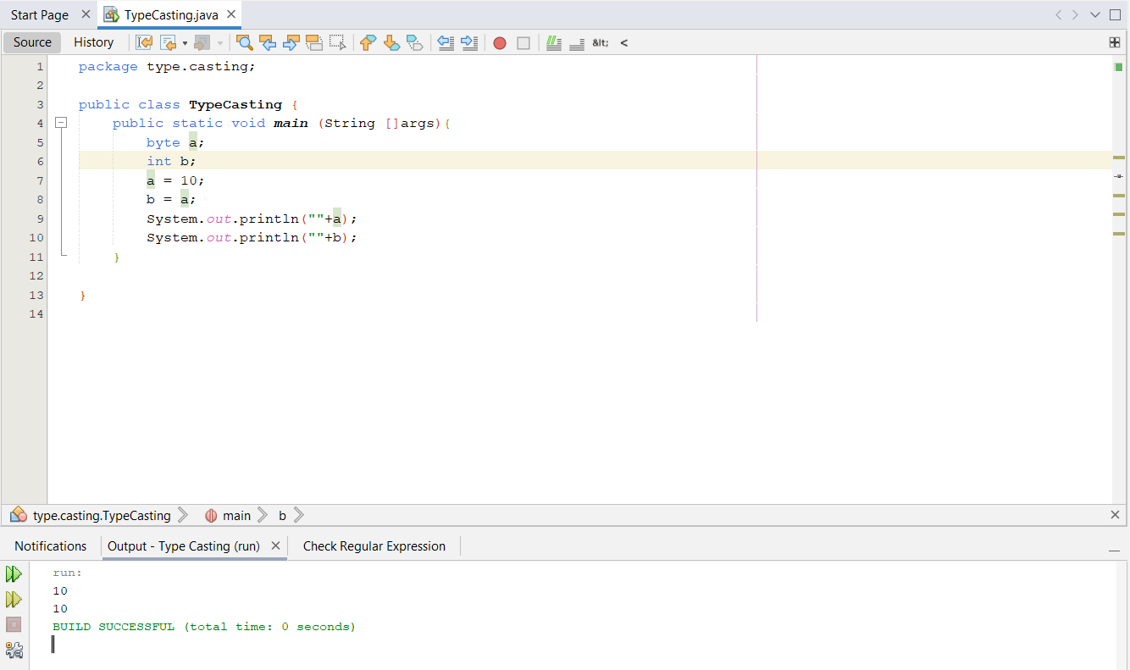

**Implicit typecasting required**

1. **byte to long**

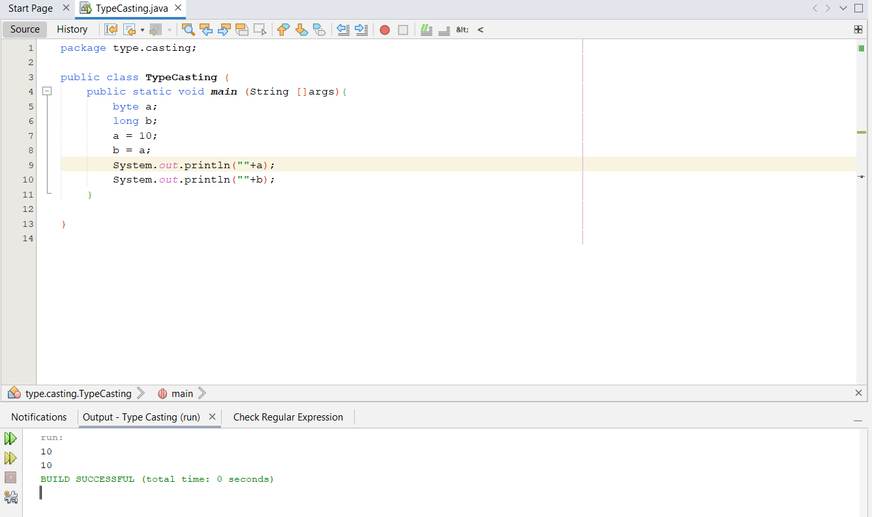

**Implicit typecasting required**

1. **byte to float**

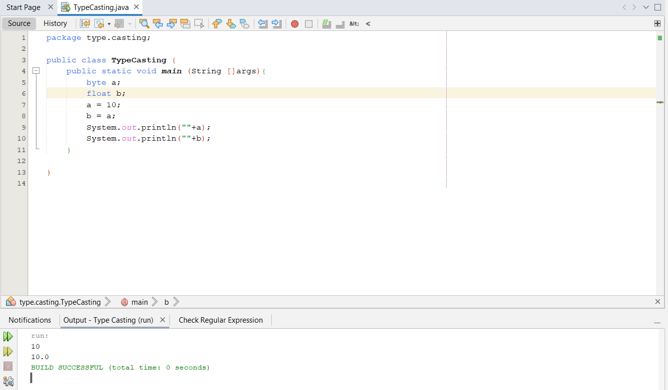

**Implicit typecasting required**

1. **byte to double**

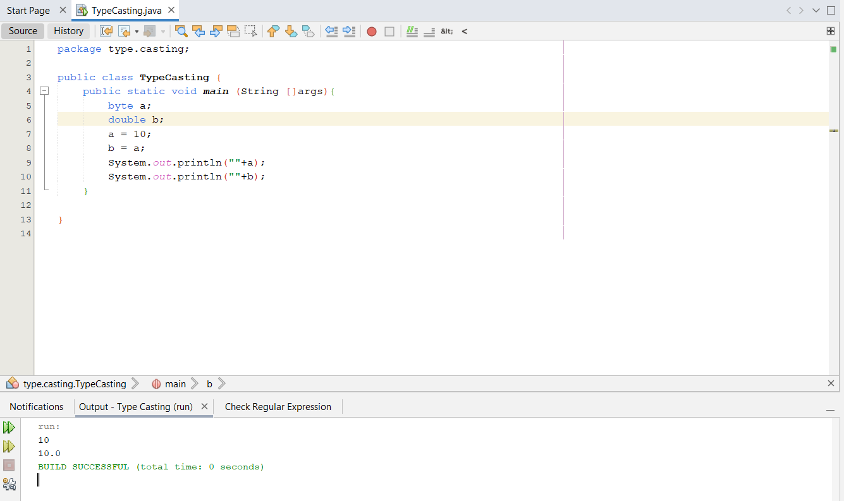

**Implicit typecasting required**

1. **byte to Boolean**

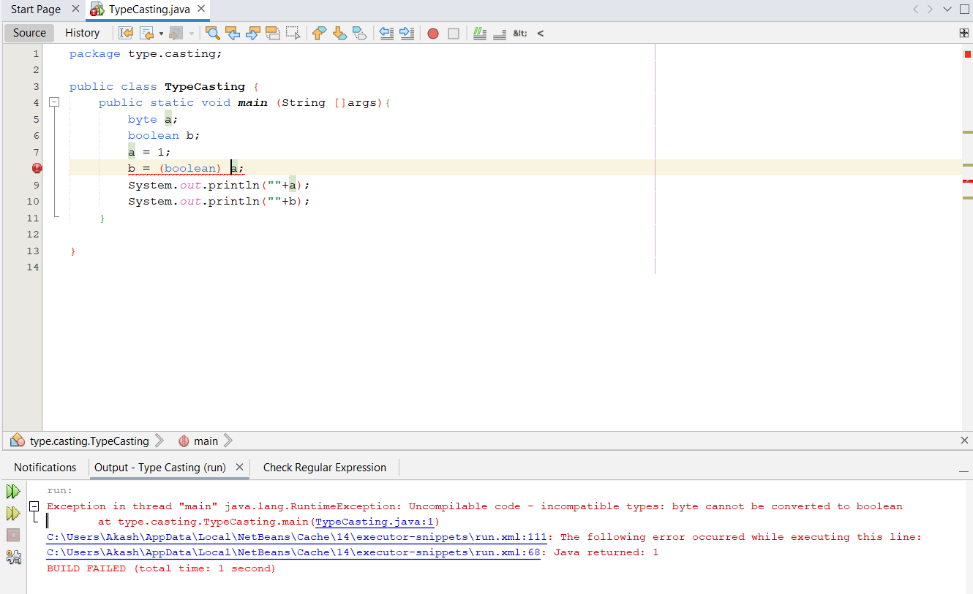

**Typecasting cannot be done**

1. **short to char**

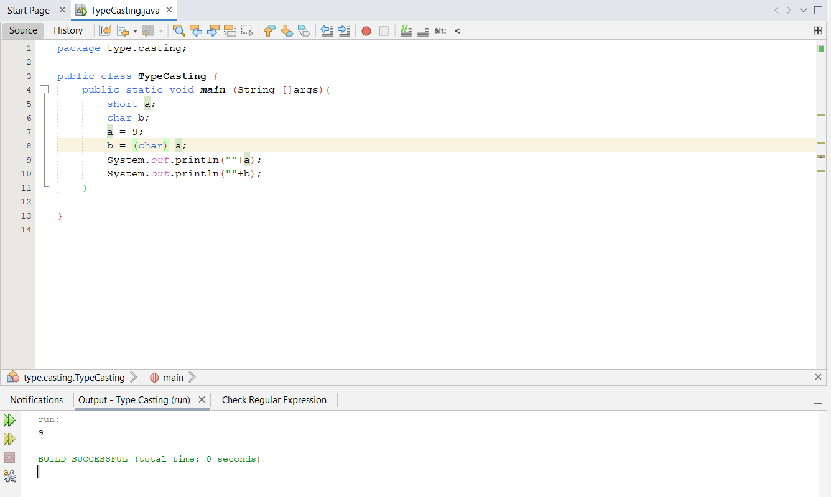

**Explicit typecasting required**

1. **short to byte**

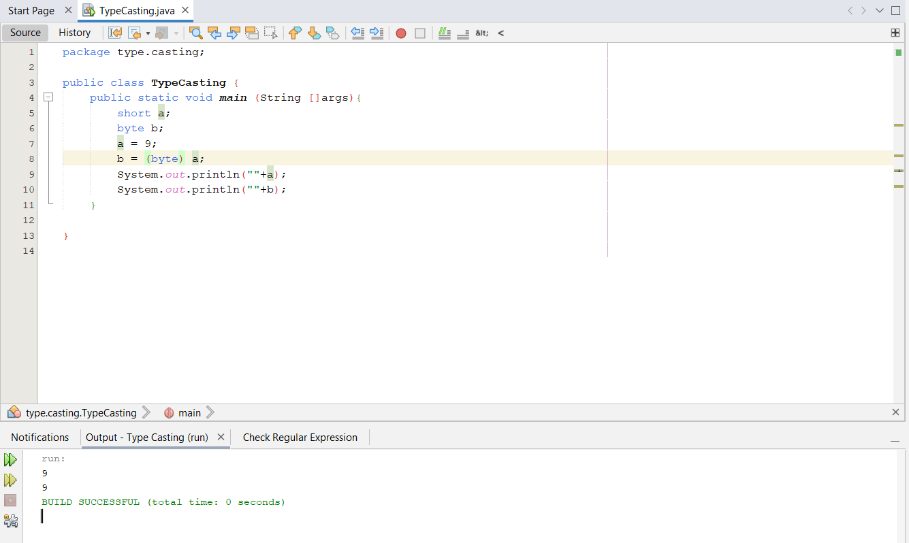

**Explicit typecasting required**

1. **short to short**

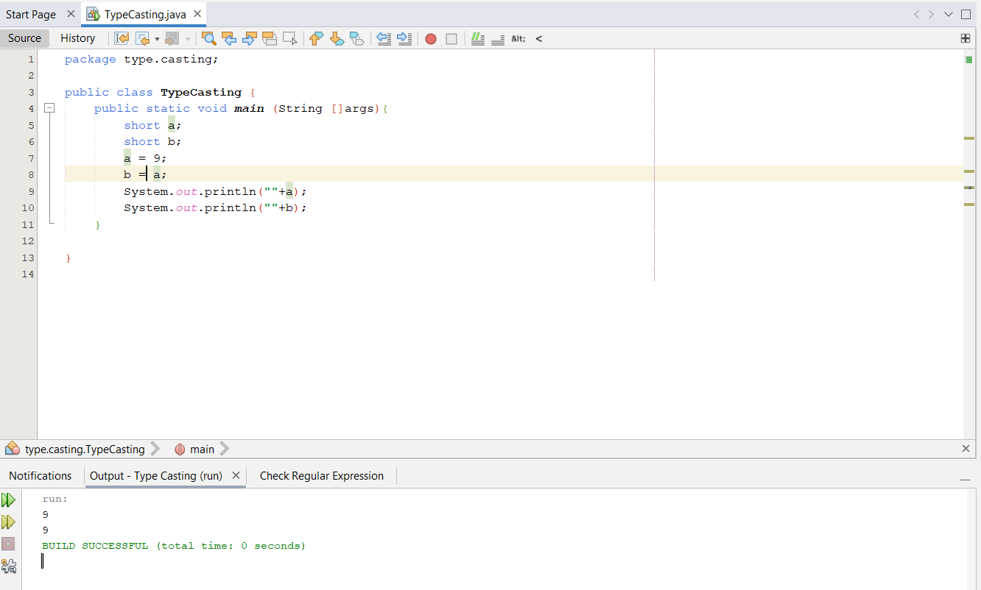

**Typecasting not required**

1. **short to int**

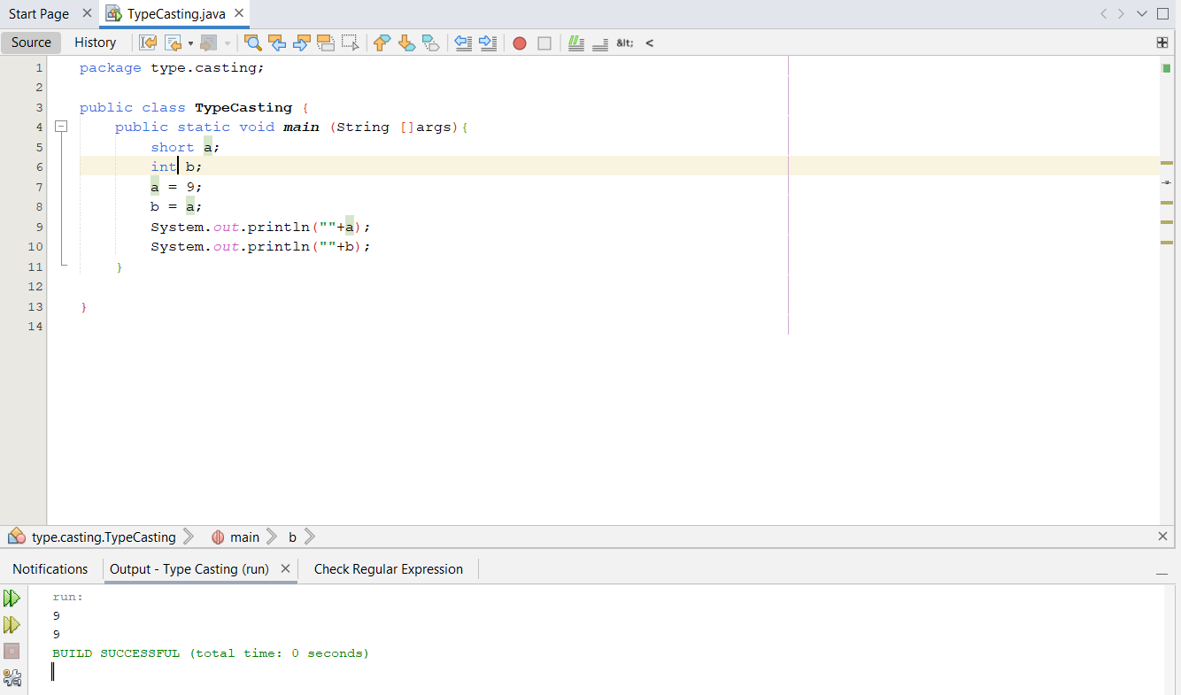**Implicit typecasting required**

1. **short to long**

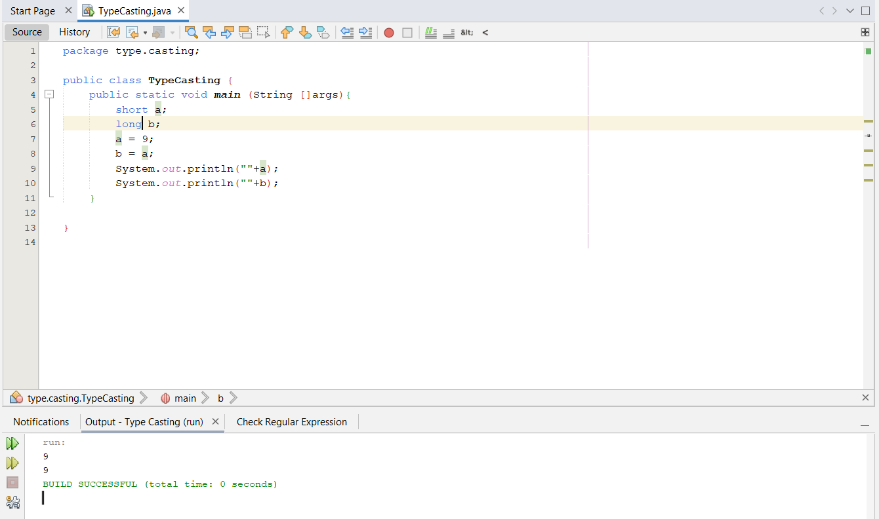

**Implicit typecasting required**

1. **short to float**

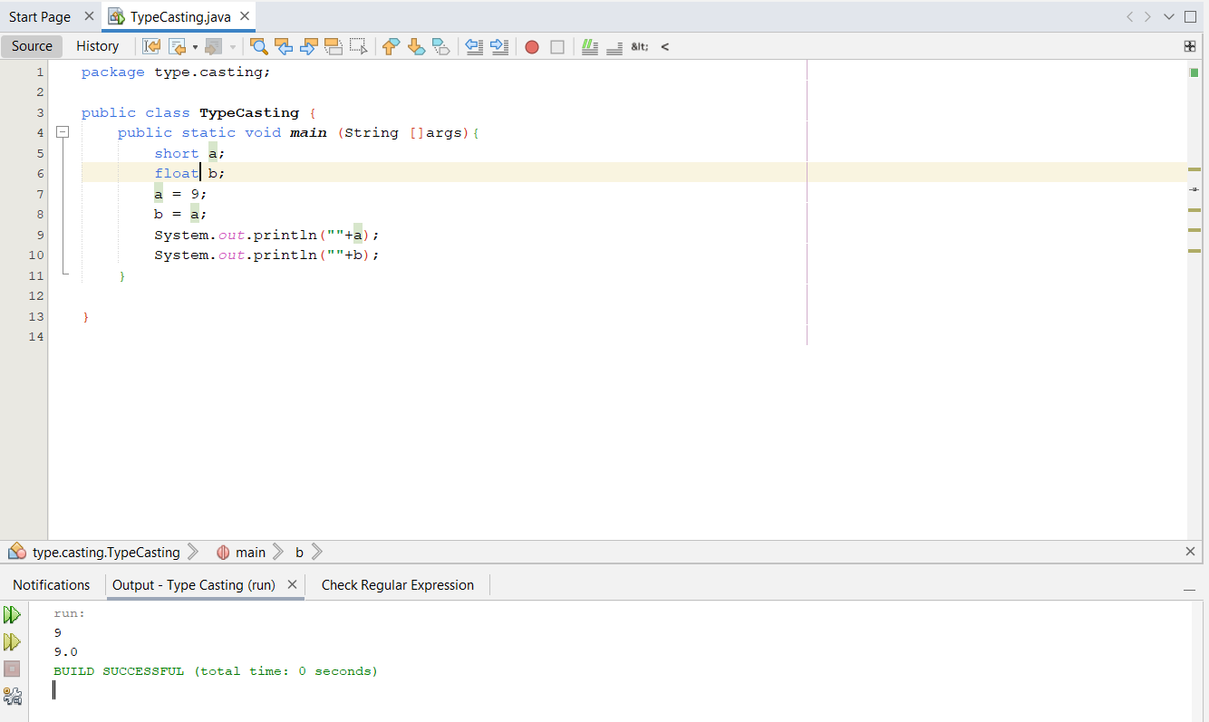

**Implicit typecasting required**

1. **short to double**

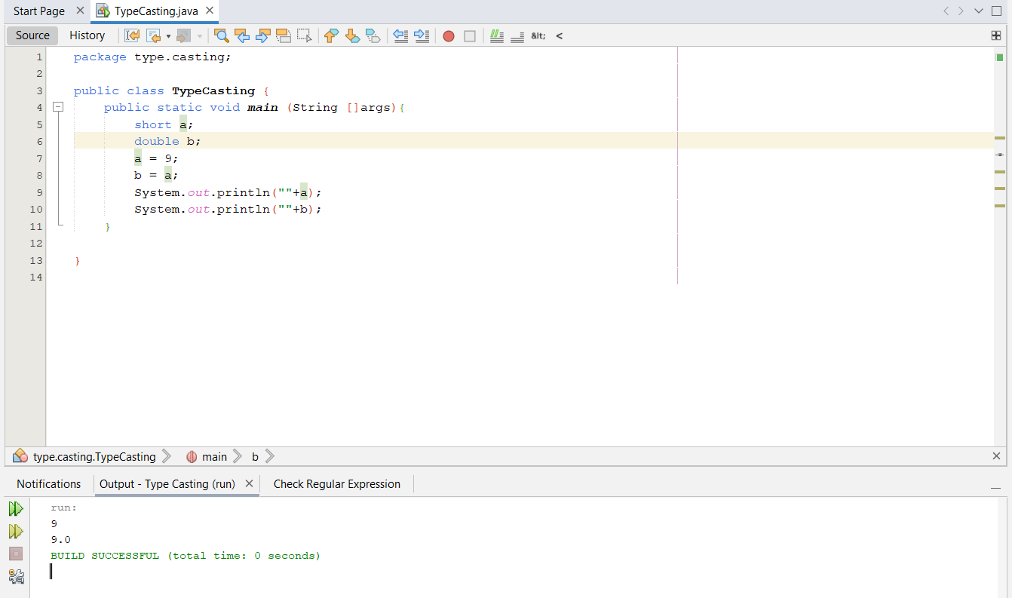

**Implicit typecasting required**

1. **short to boolean**

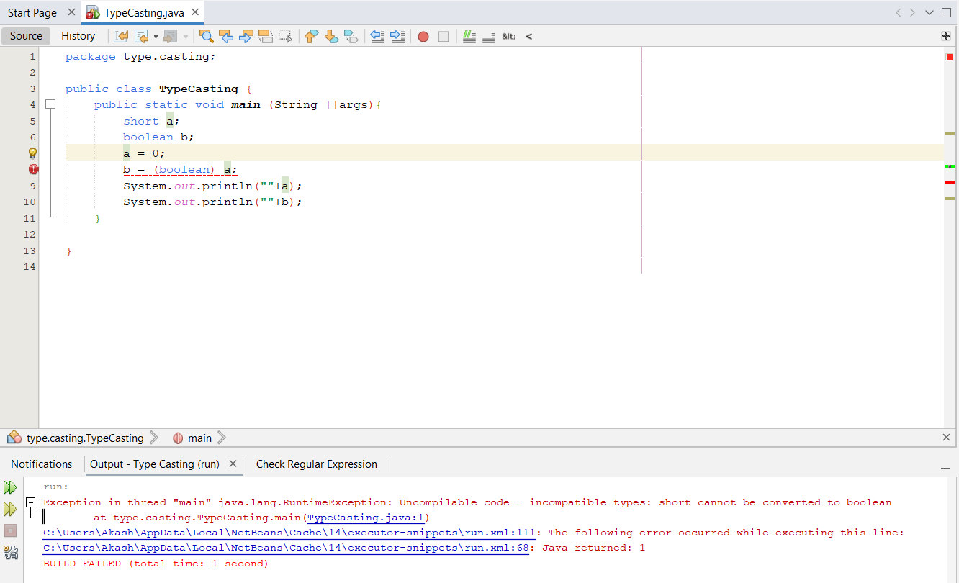

**Typecasting cannot be done**

1. **int to char**

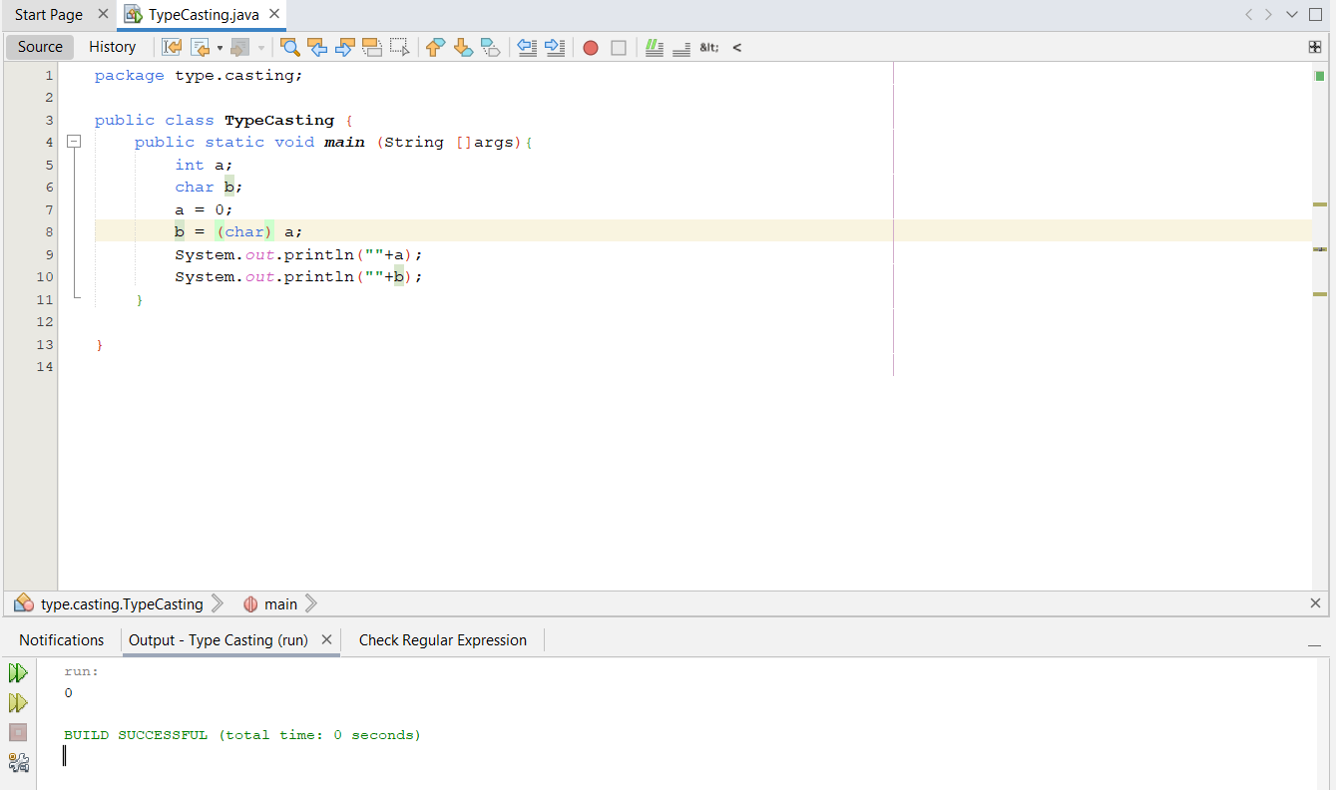

**Explicit typecasting required**

1. **int to byte**

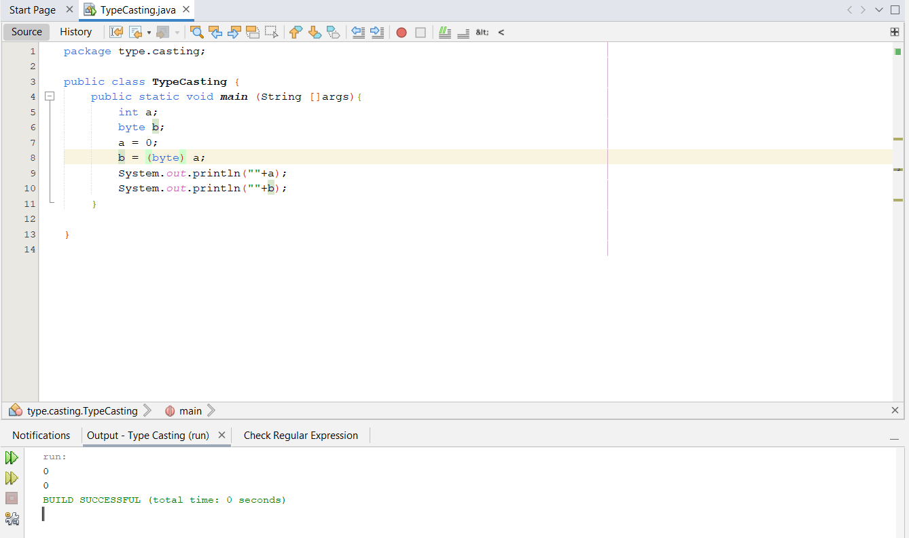

**Explicit typecasting required**

1. **int to short**

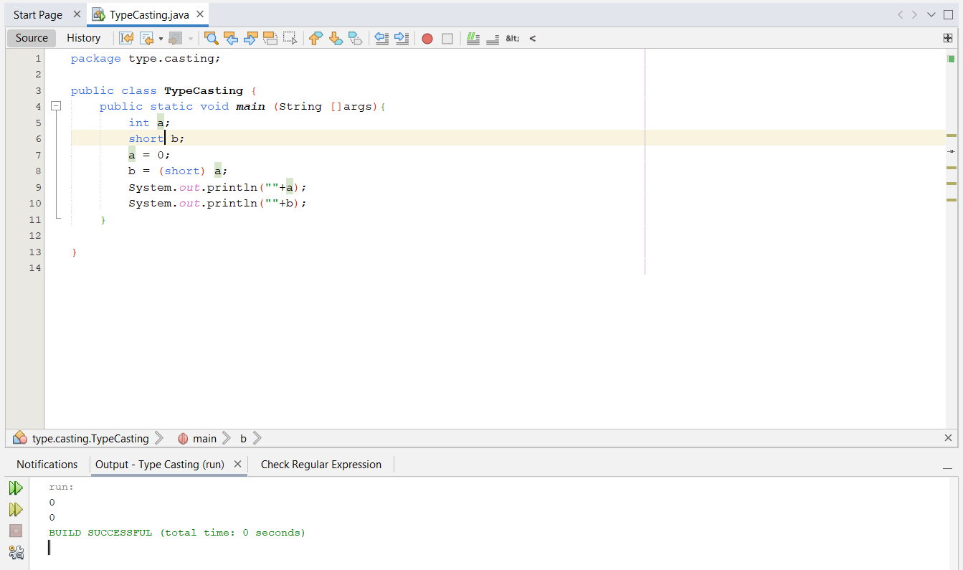

**Explicit typecasting required**

1. **int to int**

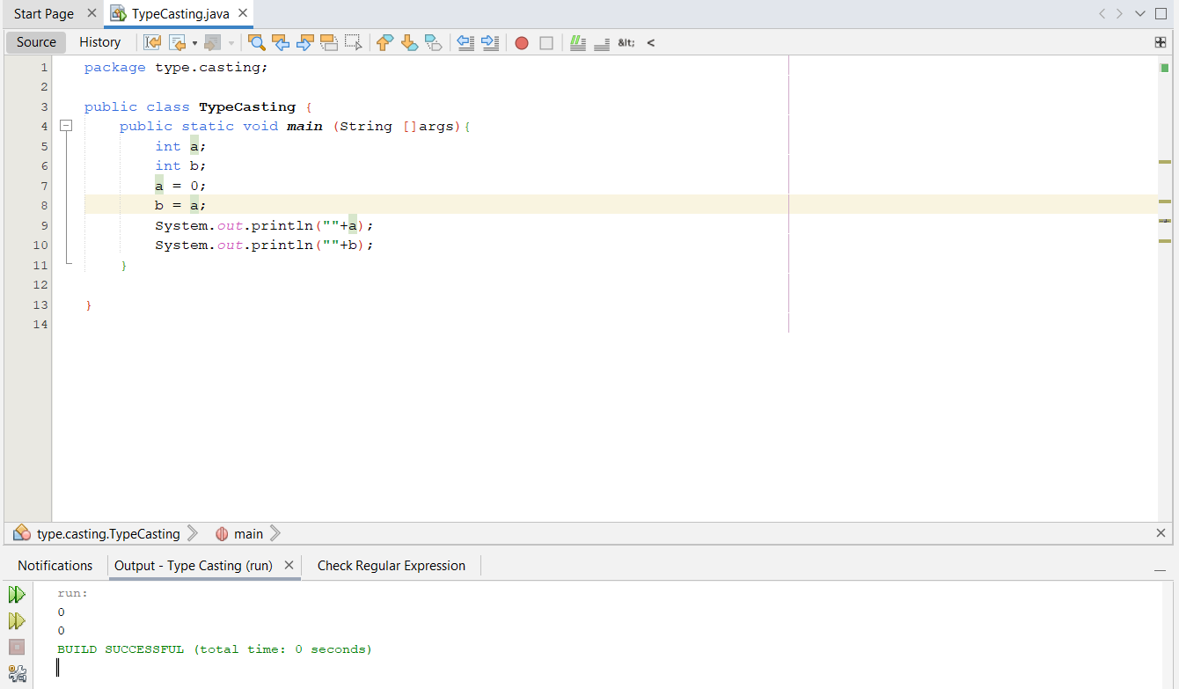

**Typecasting not required**

1. **int to long**

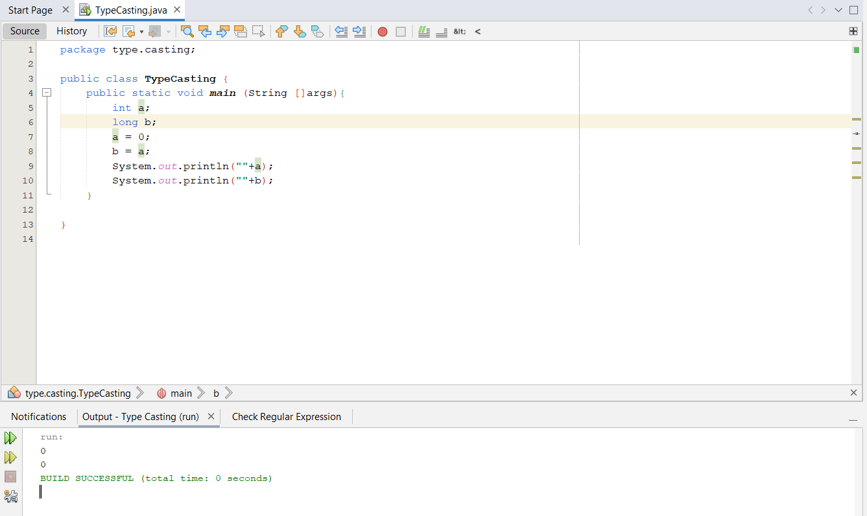

**Implicit typecasting required**

1. **int to float**

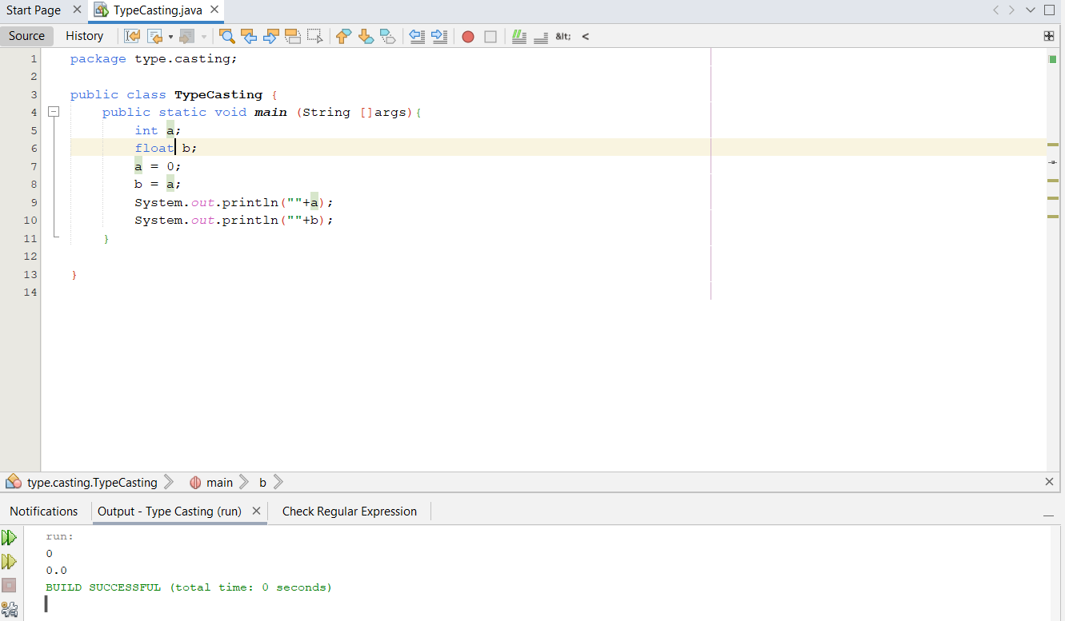

**Implicit typecasting required**

1. **int to double**

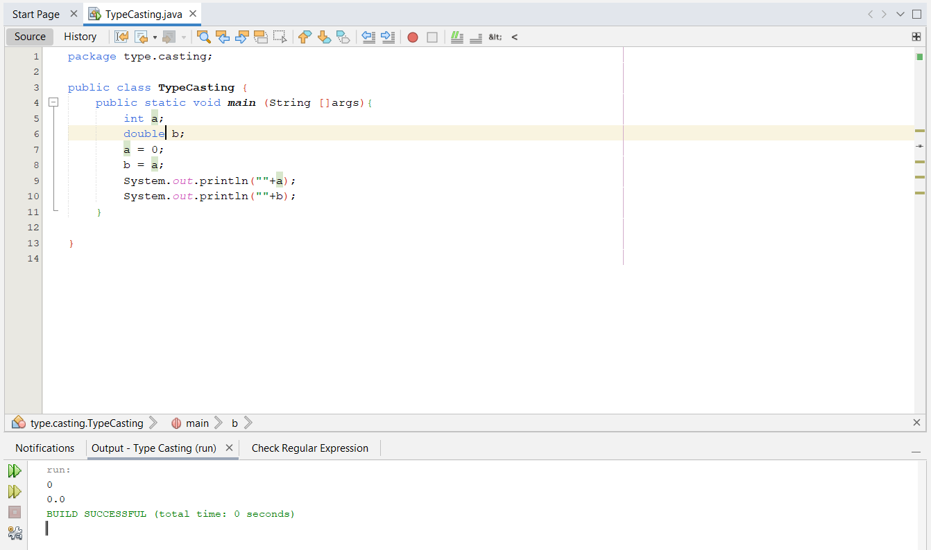

**Implicit typecasting required**

1. **int to boolean**

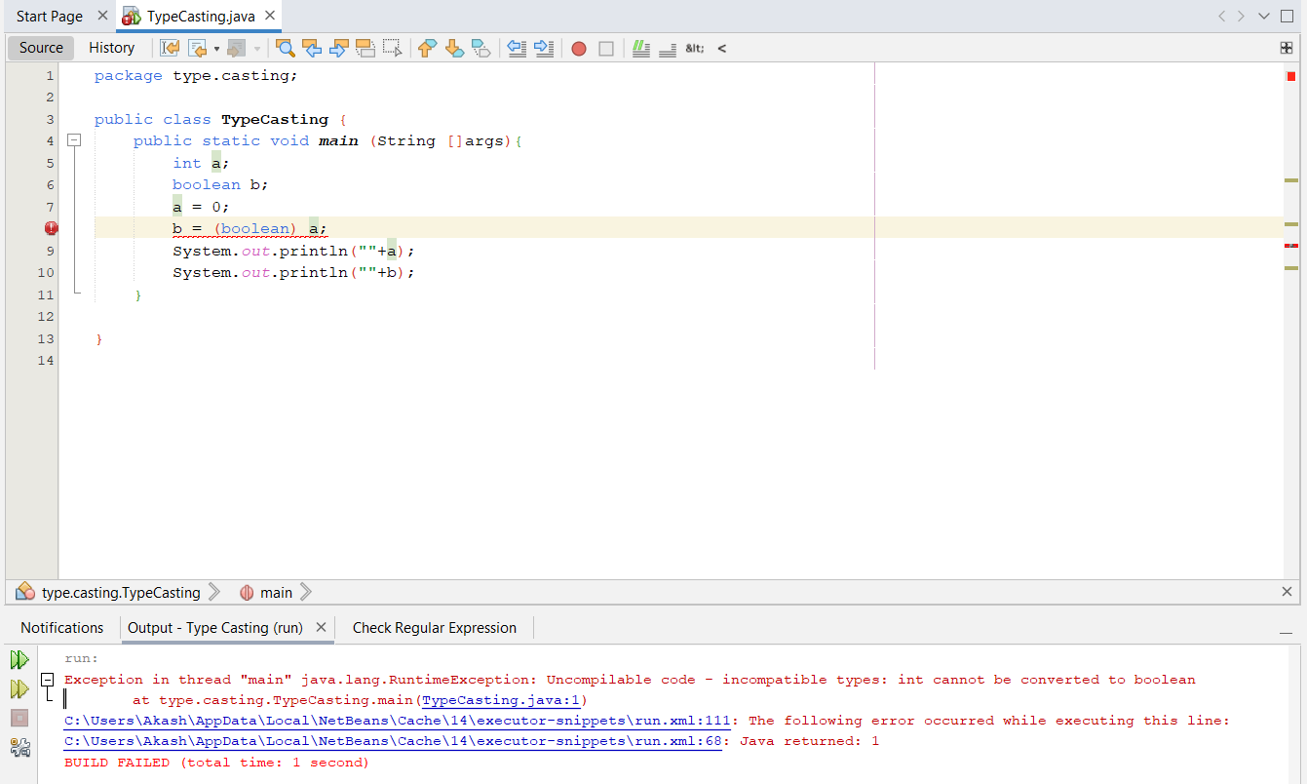

**Typecasting cannot be done**

1. **long to char**

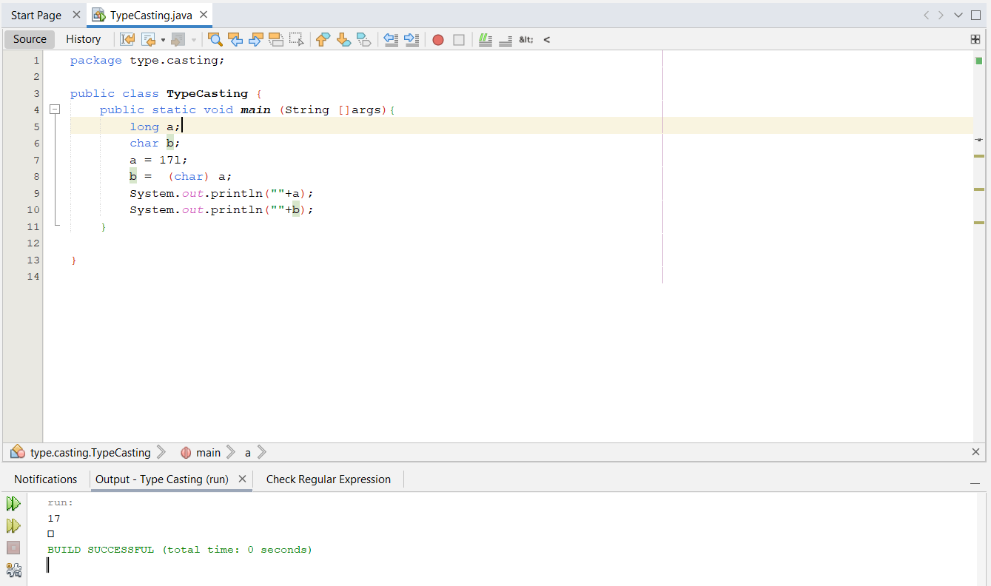

**Explicit typecasting required**

1. **long to byte**

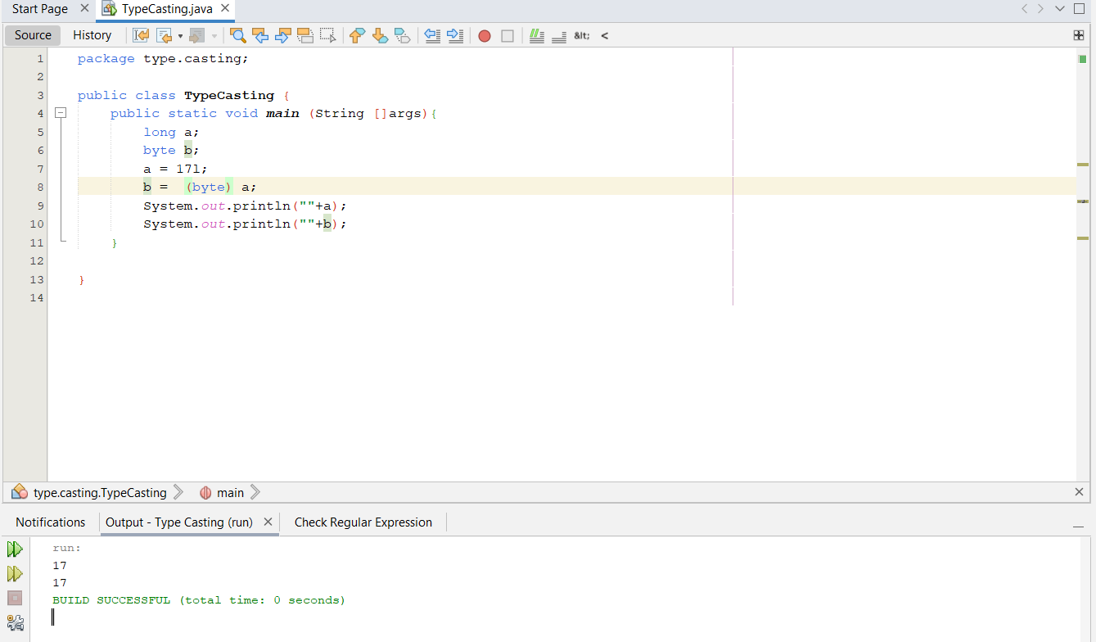

**Explicit typecasting required**

1. **long to short**

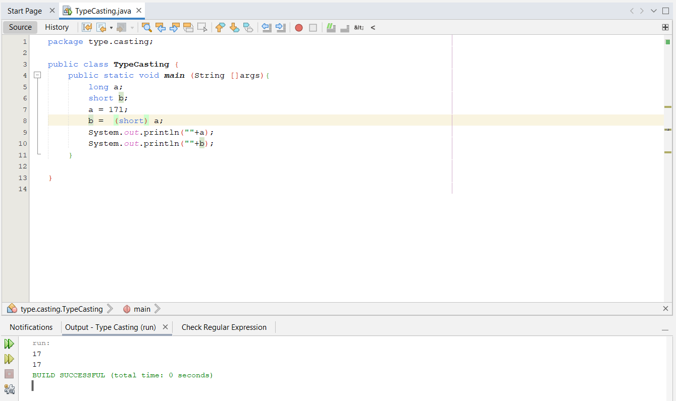

**Explicit typecasting required**

1. **long to int**

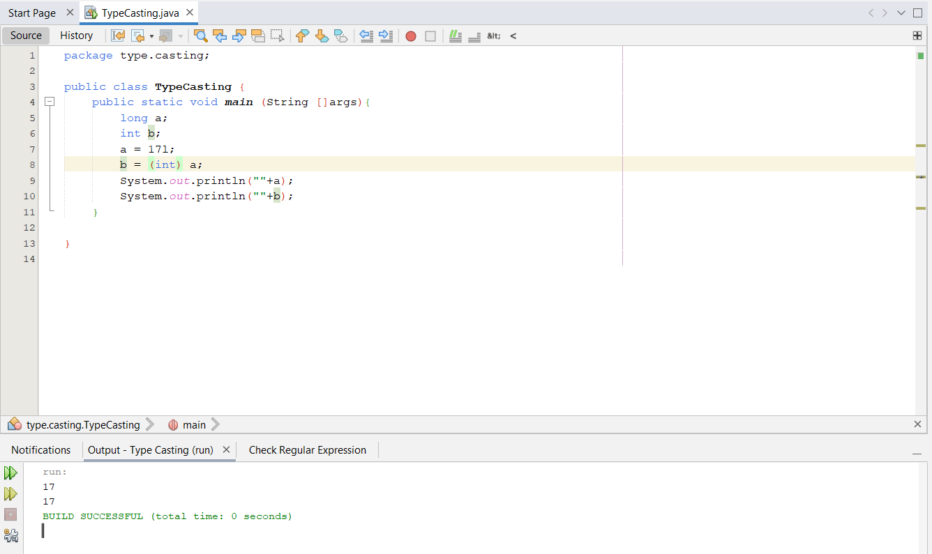

**Explicit typecasting required**

1. **long to long**

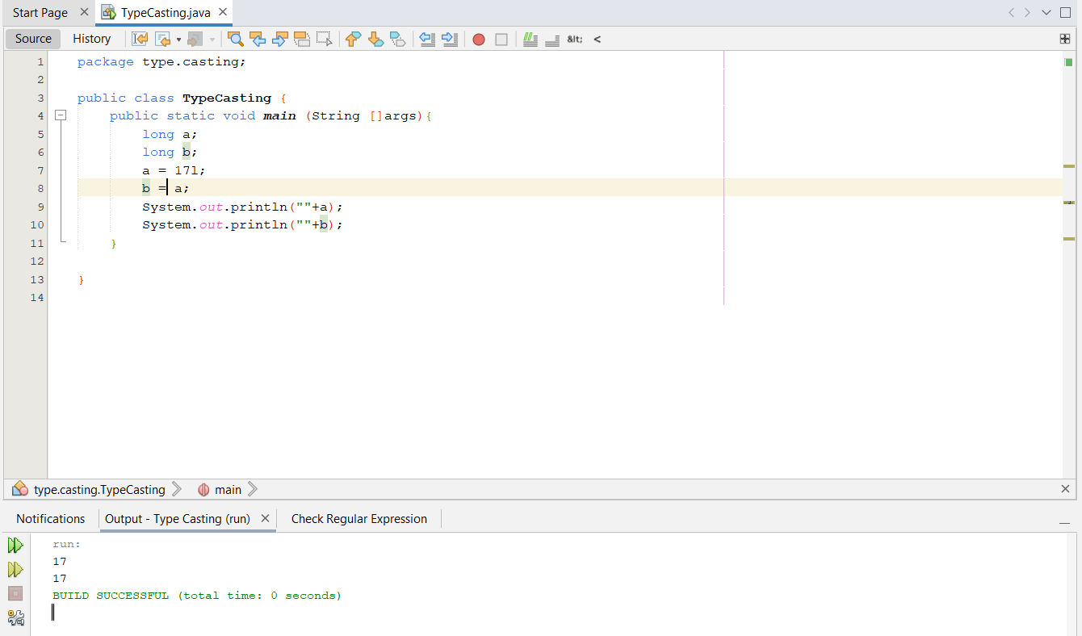

**Typecasting not required**

1. **long to float**

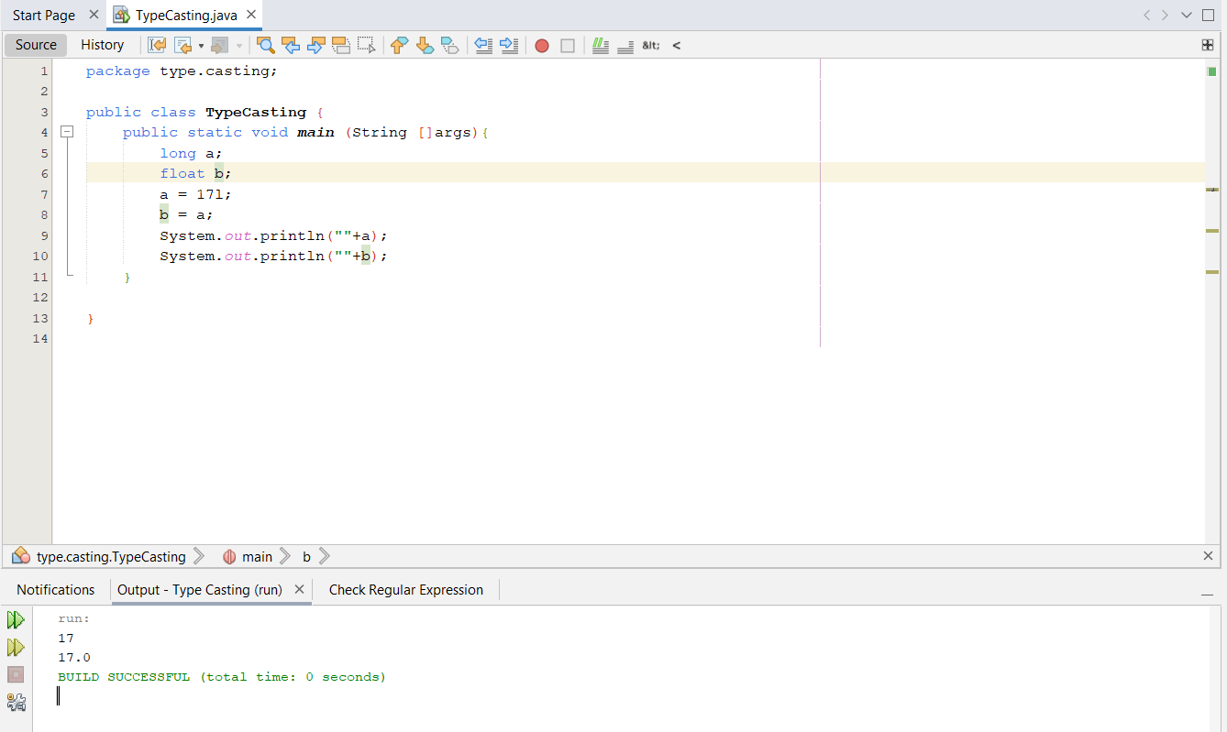

**Implicit typecasting required**

1. **long to double**

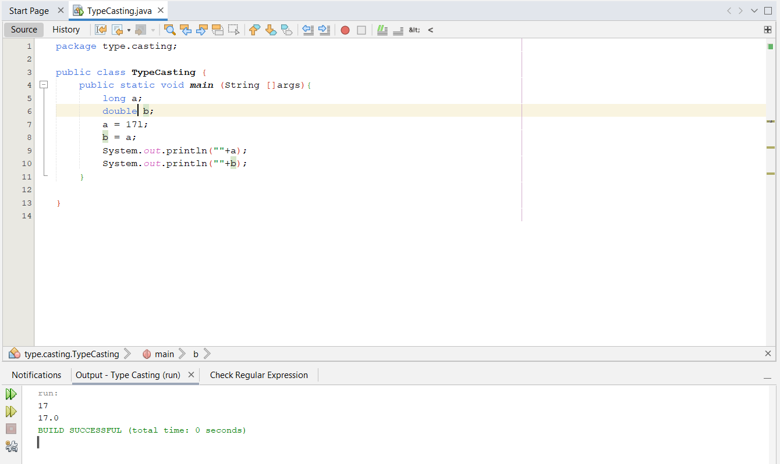

**Implicit typecasting required**

1. **long to boolean**

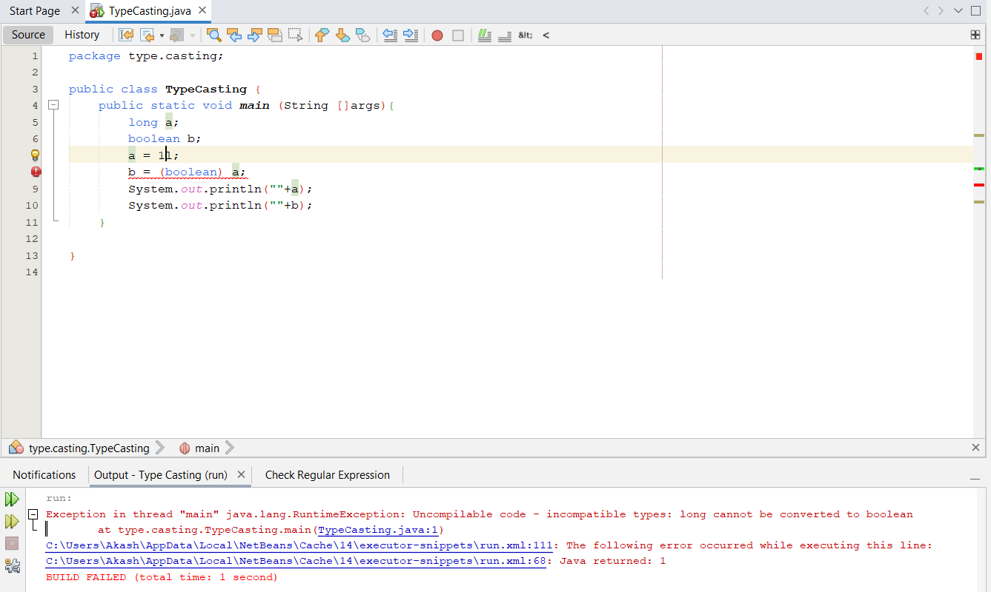

**Typecasting cannot be done**

1. **float to char**

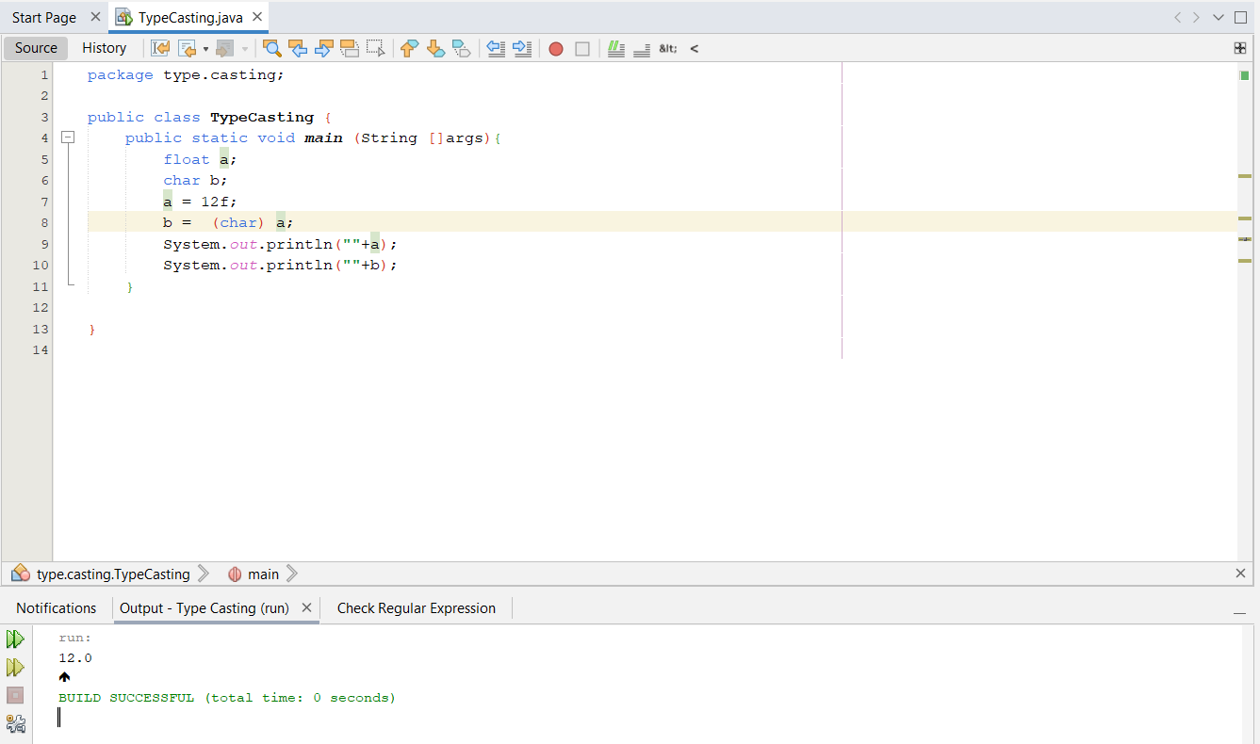

**Explicit typecasting required**

1. **float to byte**

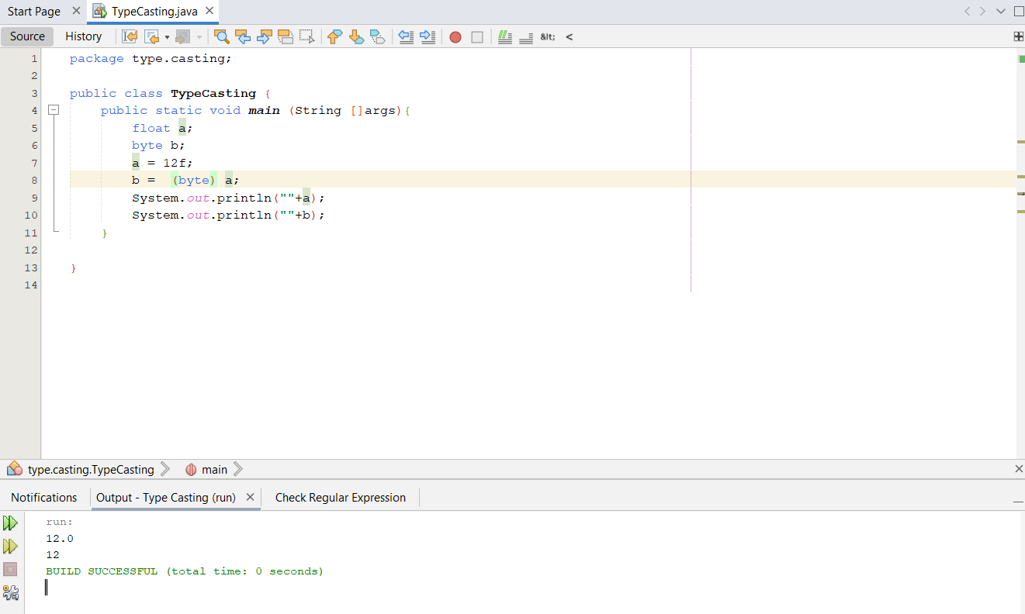

**Explicit typecasting required**

1. **float to short**

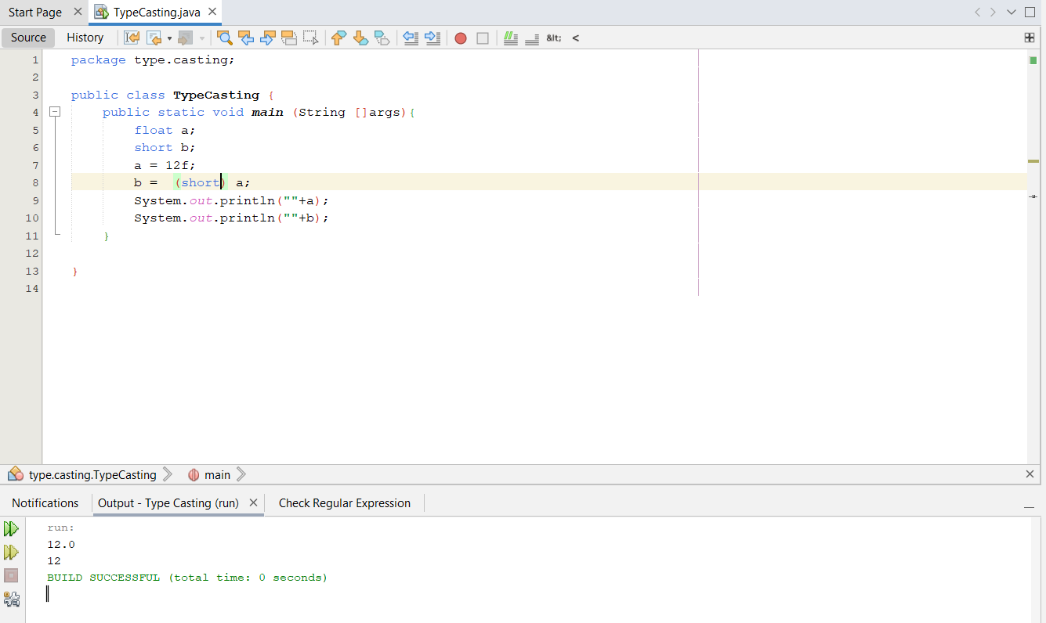

**Explicit typecasting required**

1. **float to int**

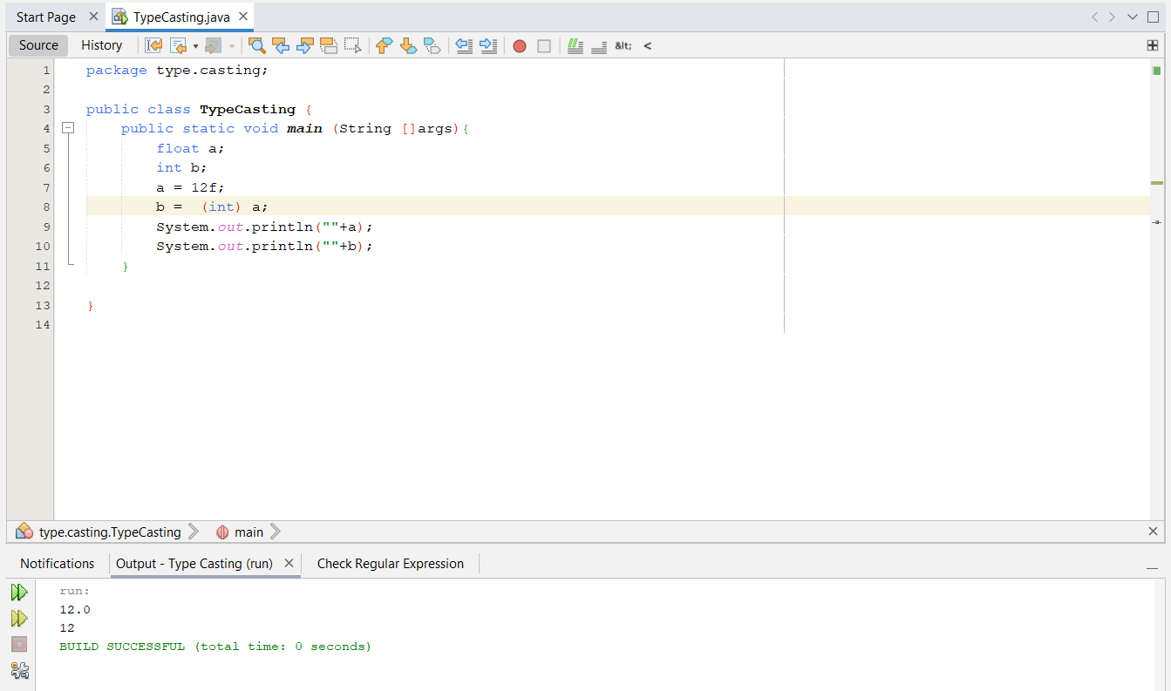

**Explicit typecasting required**

1. **float to long**

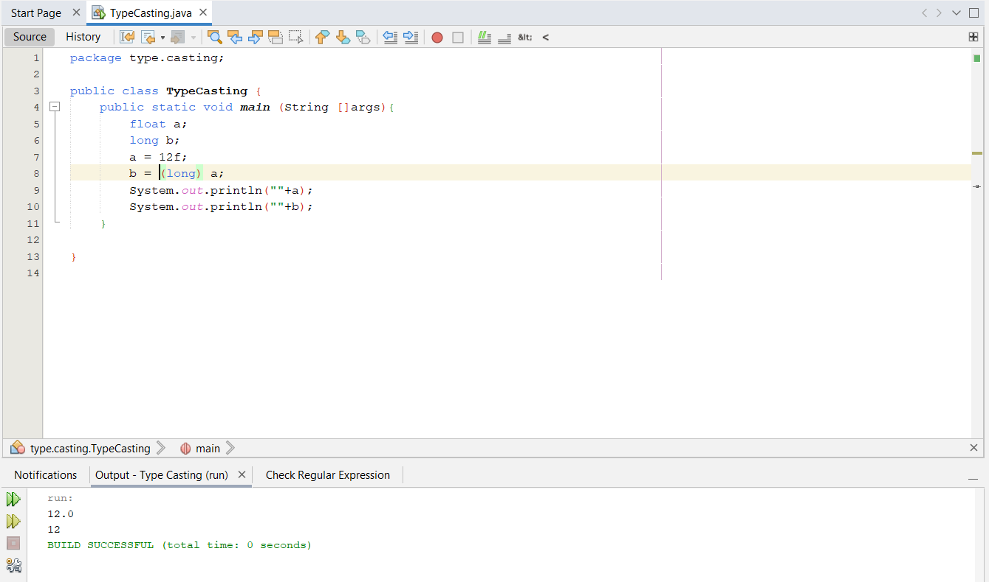

**Explicit typecasting required**

1. **float to float**

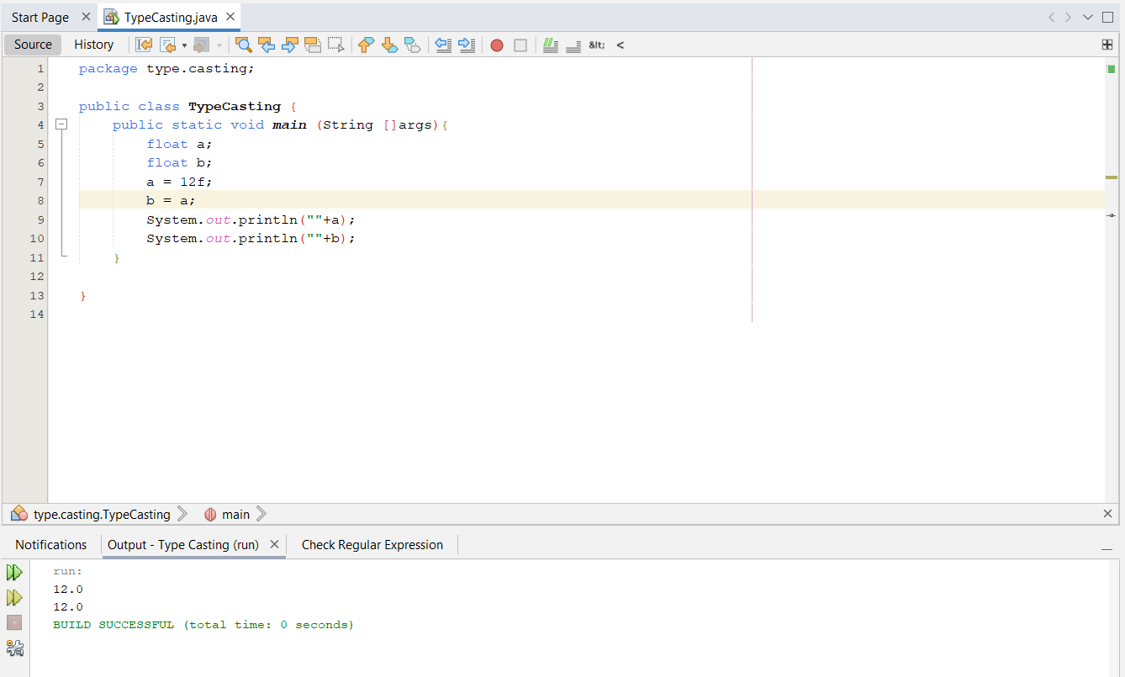

**Implicit typecasting required**

1. **float to double**

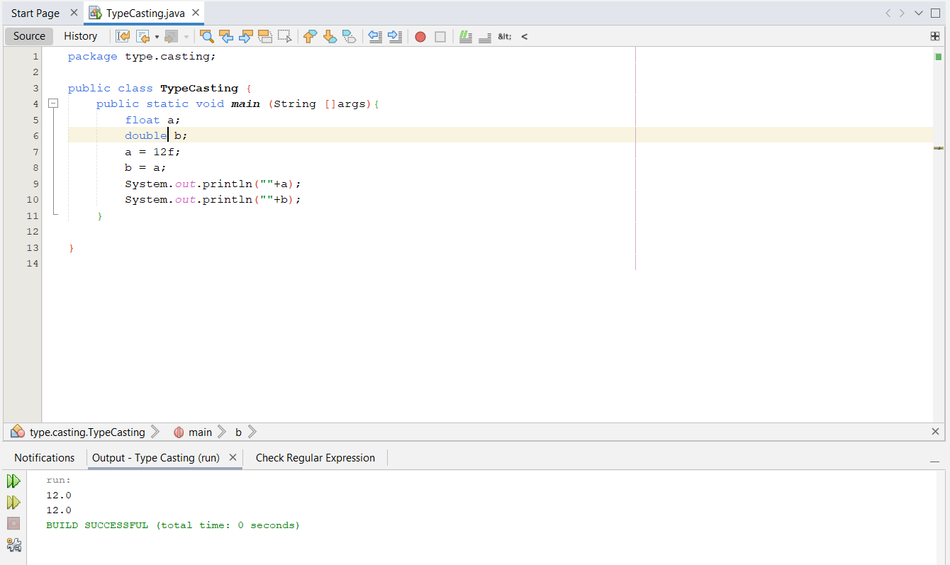

**Implicit typecasting required**

1. **float to boolean**

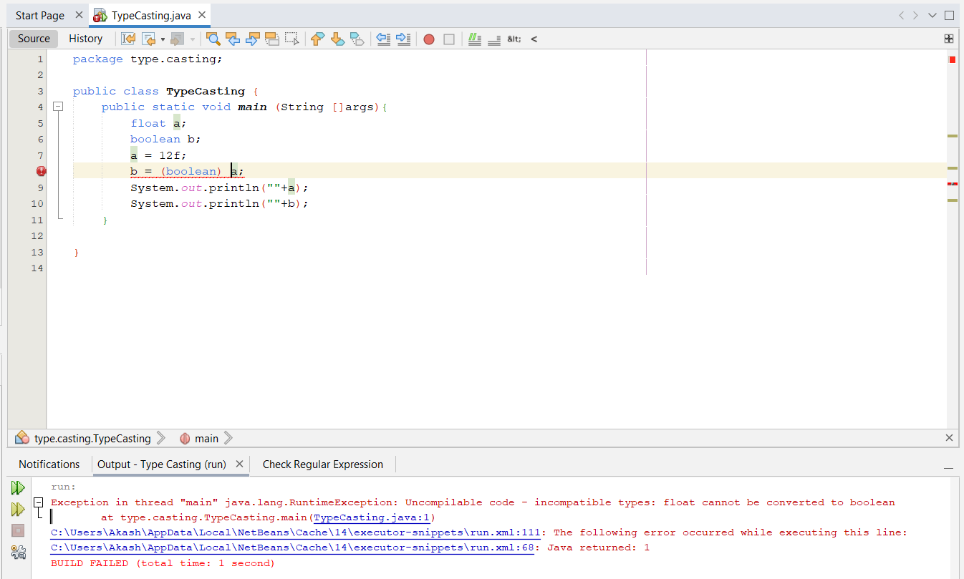

**Typecasting cannot be done**

1. **double to char**

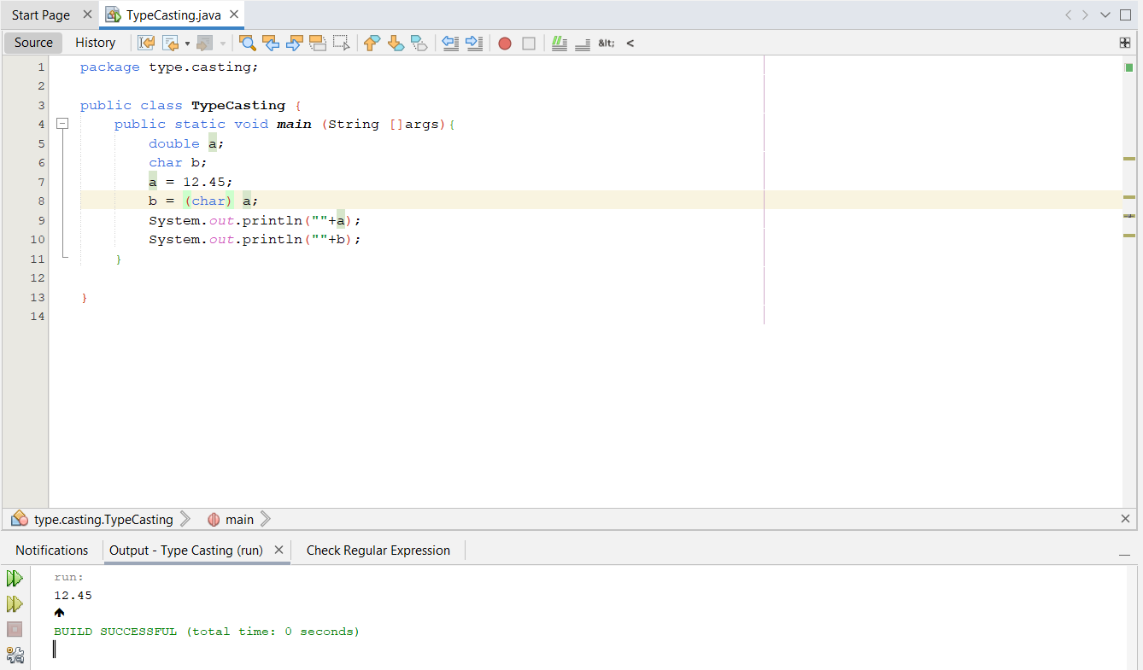

**Explicit typecasting required**

1. **double to byte**

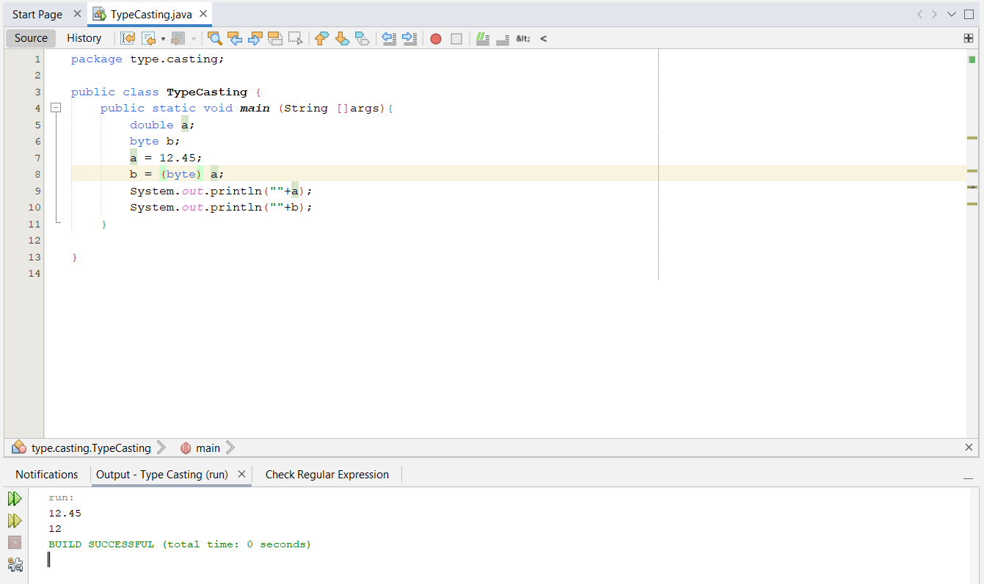

**Explicit typecasting required**

1. **double to short**

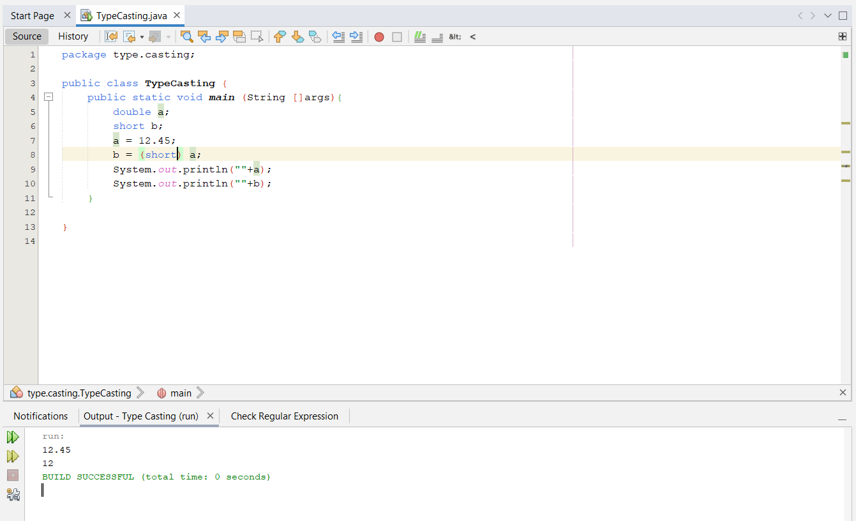

**Explicit typecasting required**

1. **double to int**

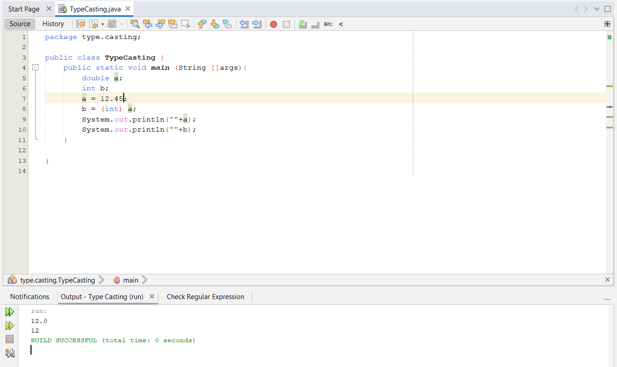

**Explicit typecasting required**

1. **double to long**

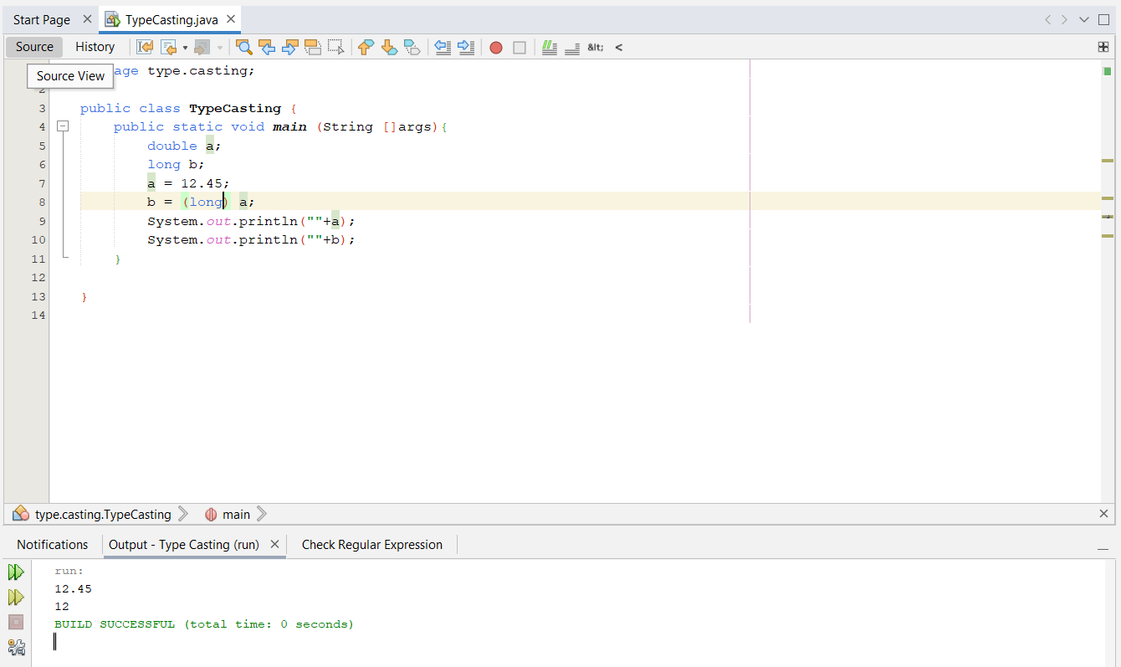

**Explicit typecasting required**

1. **double to float**

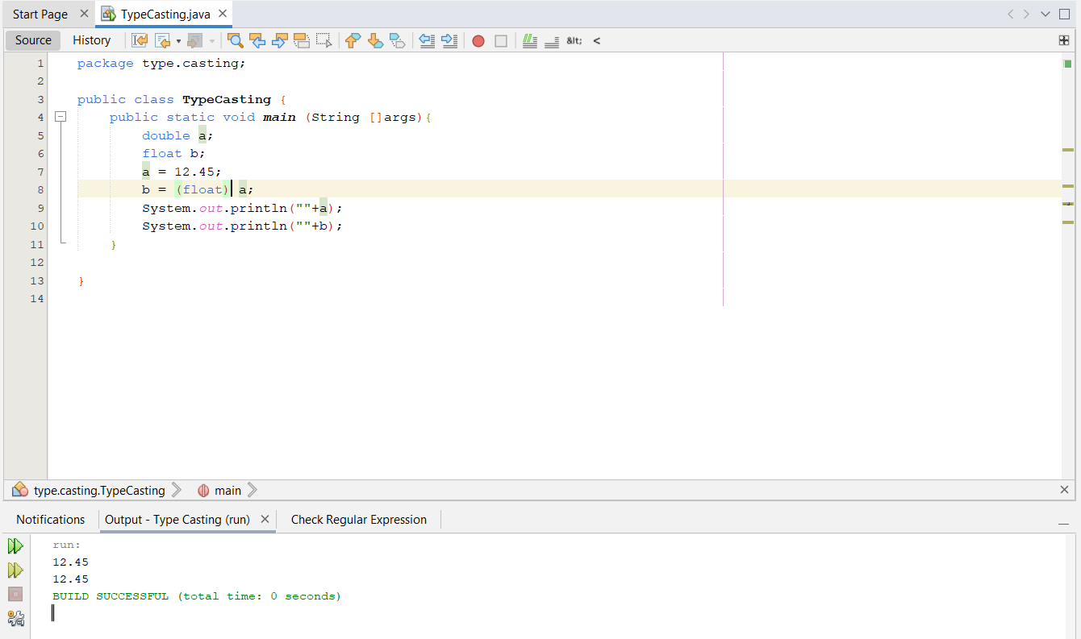

**Explicit typecasting required**

1. **double to double**

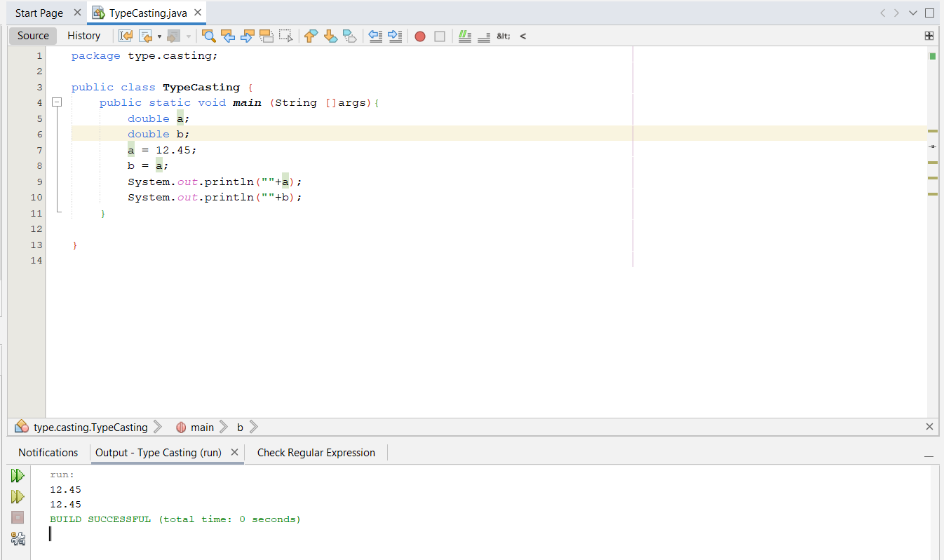

**Typecasting not required**

1. **double to boolean**

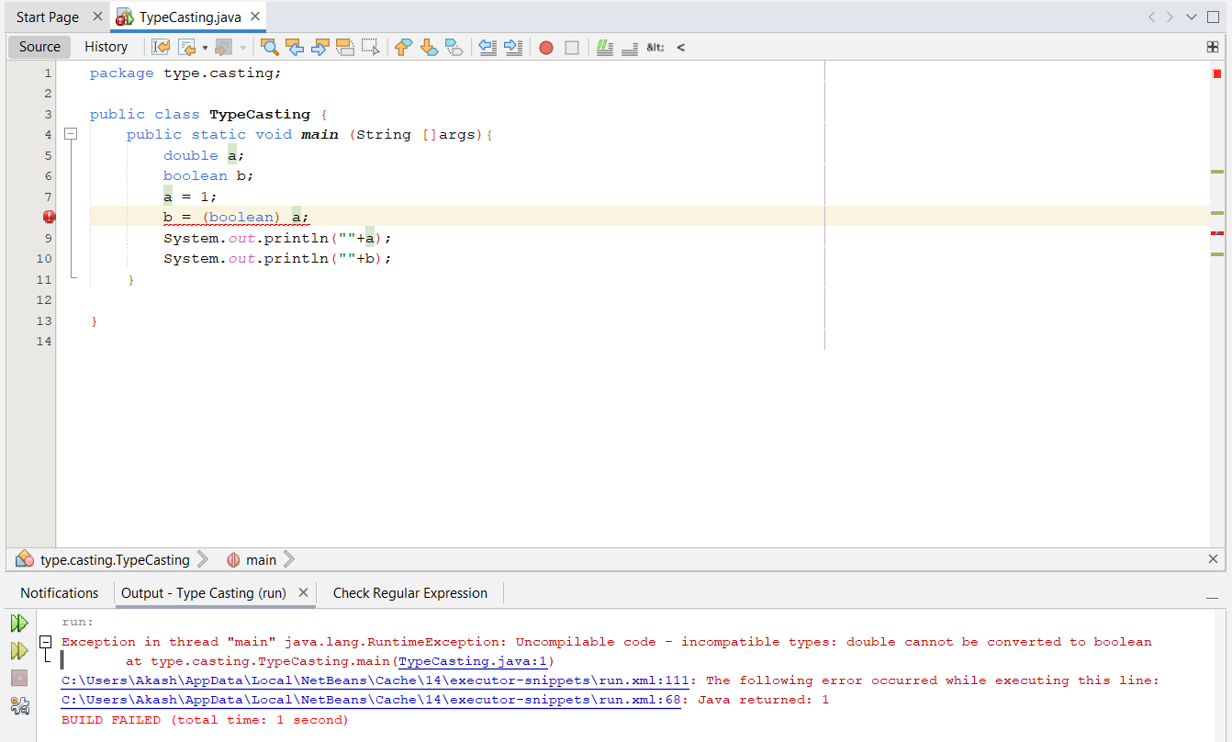

**Typecasting cannot be done**

1. **boolean to char**

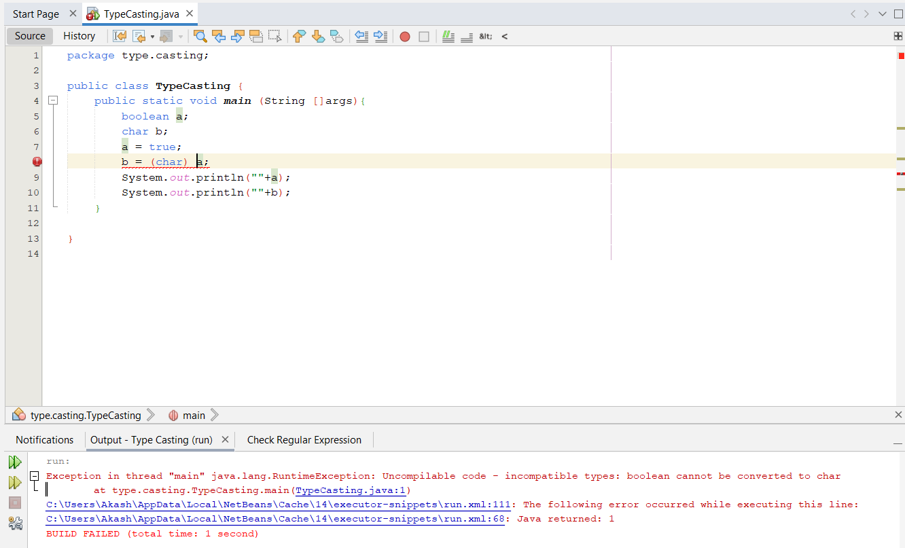

**Typecasting cannot be done**

1. **boolean to byte**

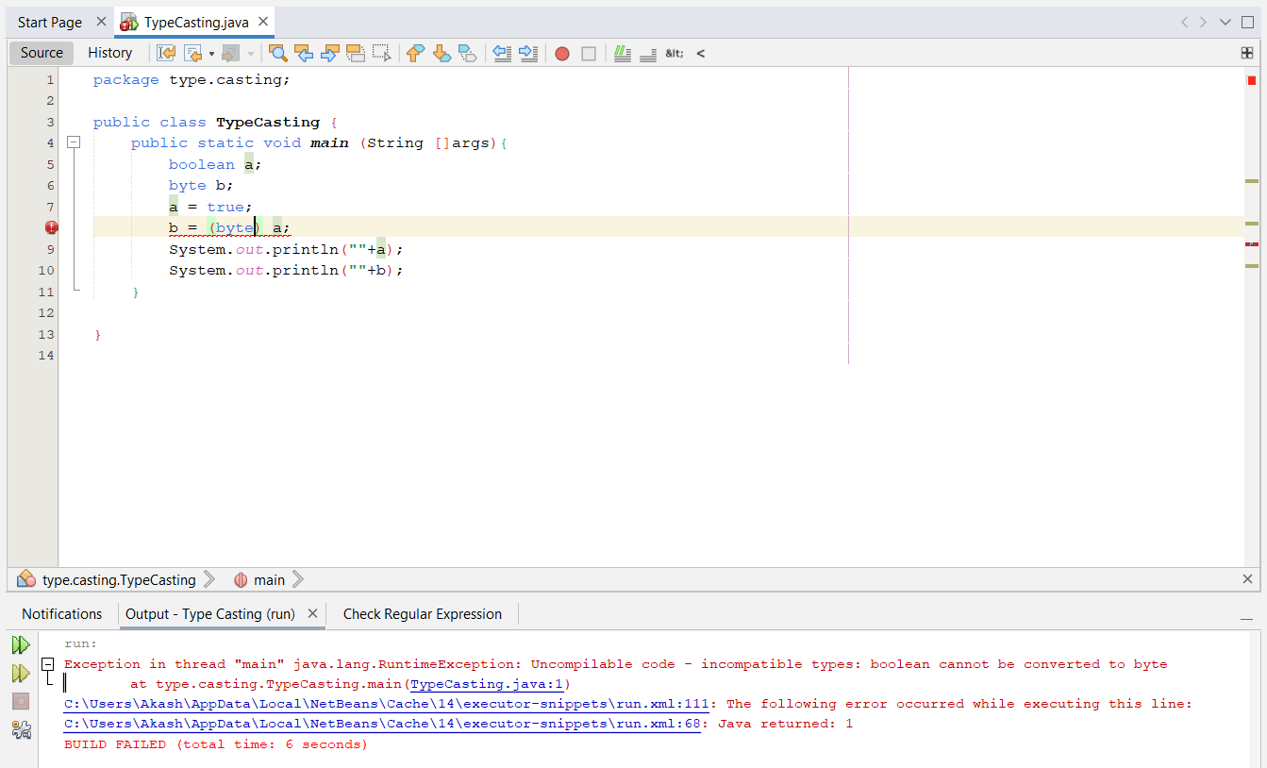

**Typecasting cannot be done**

1. **boolean to short**

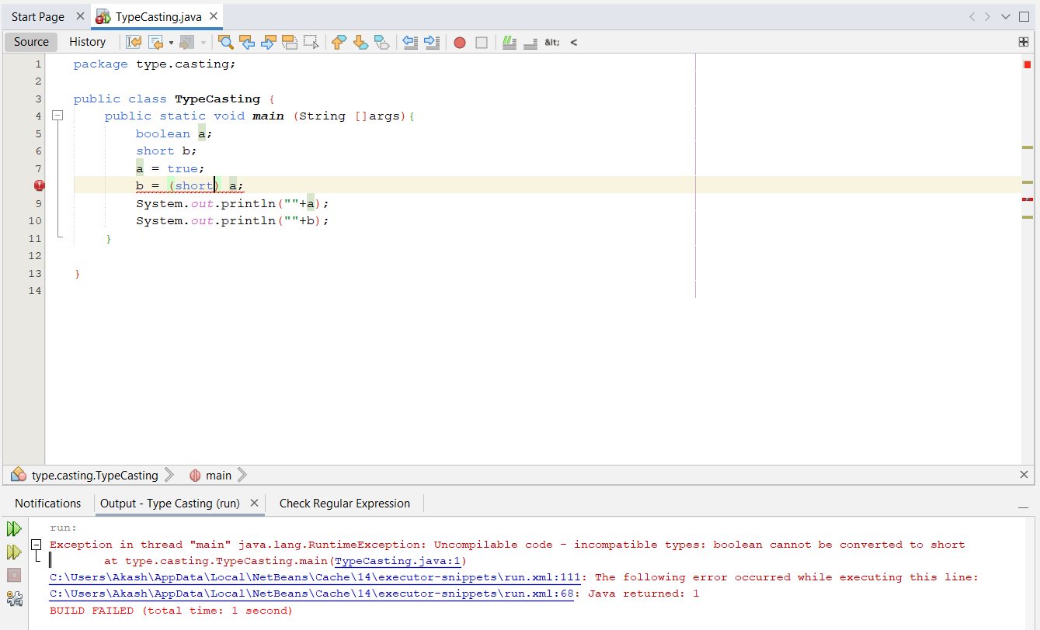

**Typecasting cannot be done**

1. **boolean to int**

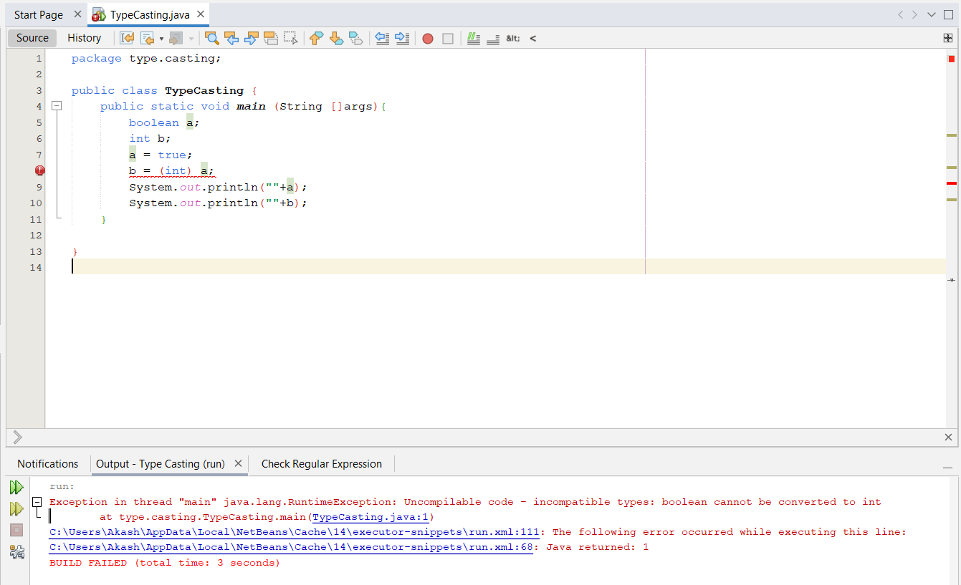

**Typecasting cannot be done**

1. **boolean to long**

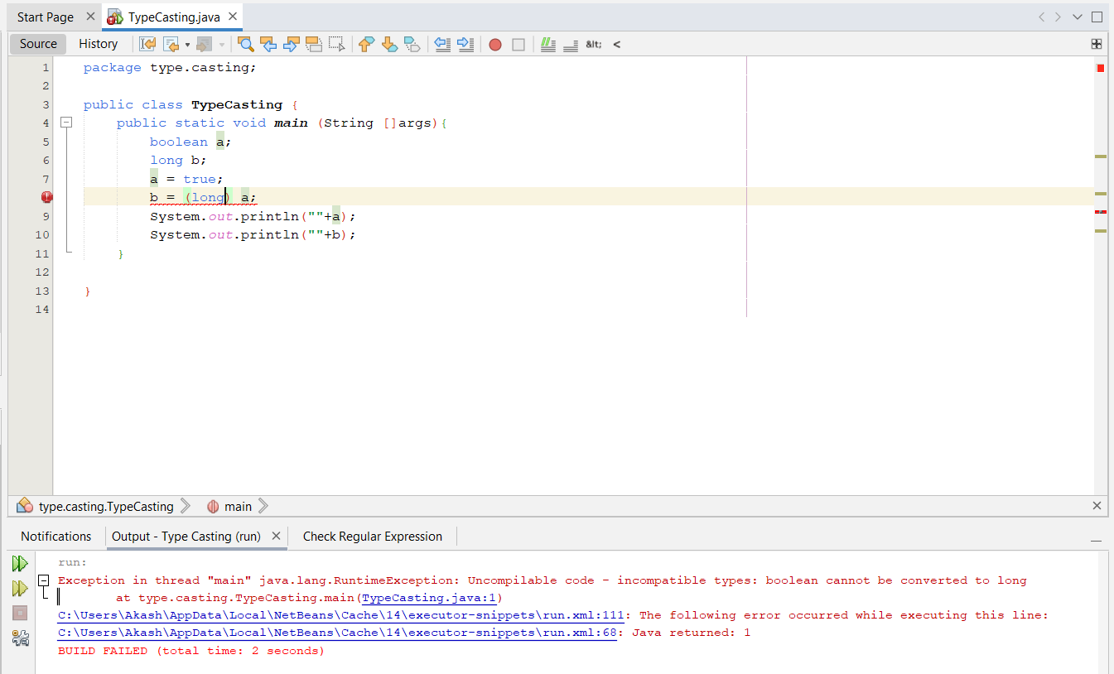

**Typecasting cannot be done**

1. **boolean to float  
   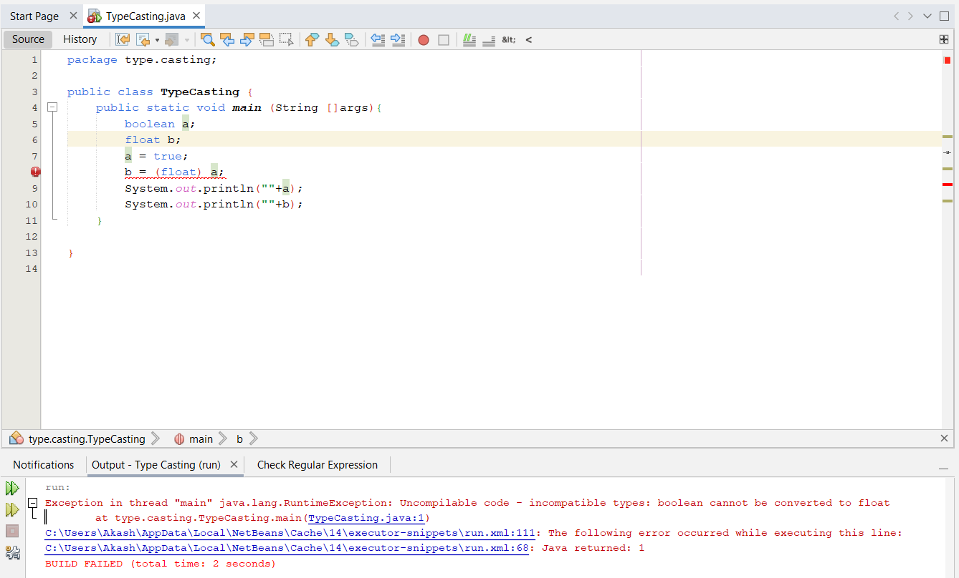**

**Typecasting cannot be done**

1. **boolean to double**

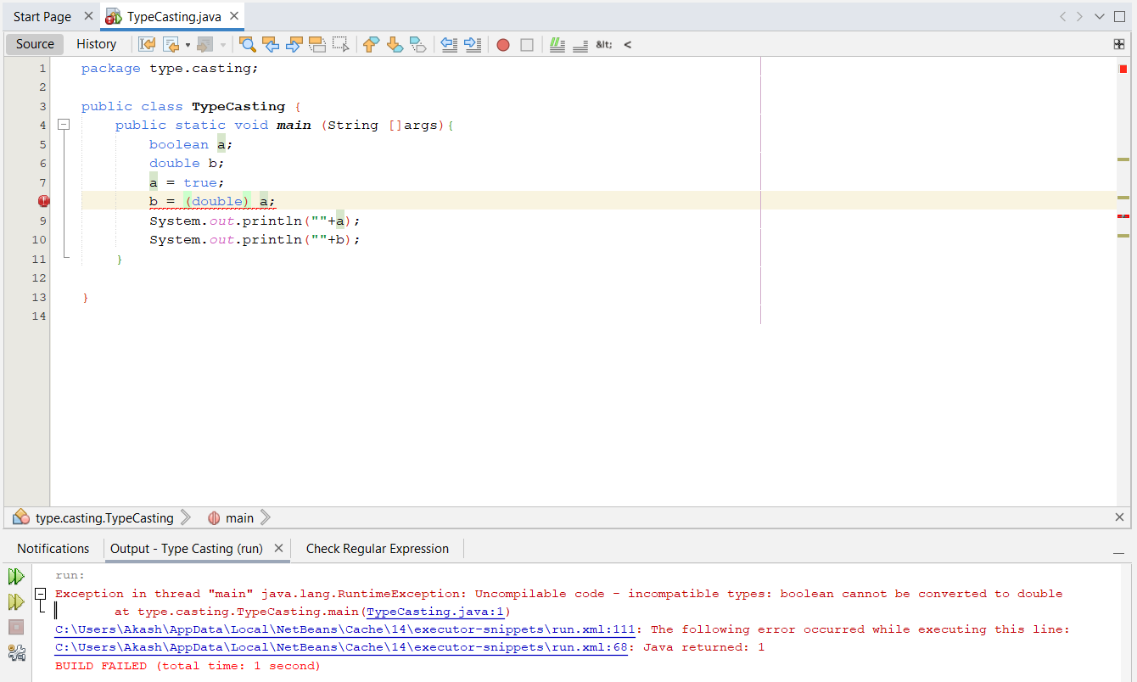

**Typecasting cannot be done**

1. **boolean to boolean**

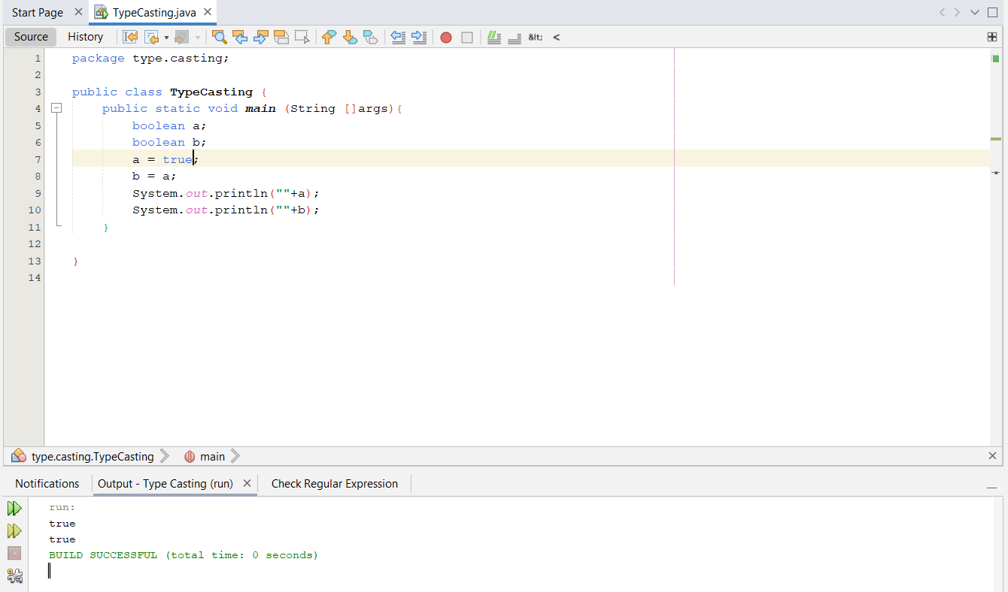

**Typecasting not required**

**Implicit Typecasting:**

**Explicit Typecasting:**

**Conclusion:**

|  |  |  |  |  |  |  |  |  |
| --- | --- | --- | --- | --- | --- | --- | --- | --- |
|  | **char** | **byte** | **short** | **int** | **long** | **float** | **double** | **boolean** |
| **char** | **-** | **✓** | **✓** | **✓** | **✓** | **✓** | **✓** | **✕** |
| **byte** | **✓** | **-** | **✓** | **✓** | **✓** | **✓** | **✓** | **✕** |
| **short** | **✓** | **✓** | **-** | **✓** | **✓** | **✓** | **✓** | **✕** |
| **int** | **✓** | **✓** | **✓** | **-** | **✓** | **✓** | **✓** | **✕** |
| **long** | **✓** | **✓** | **✓** | **✓** | **-** | **✓** | **✓** | **✕** |
| **float** | **✓** | **✓** | **✓** | **✓** | **✓** | **-** | **✓** | **✕** |
| **double** | **✓** | **✓** | **✓** | **✓** | **✓** | **✓** | **-** | **✕** |
| **boolean** | **✕** | **✕** | **✕** | **✕** | **✕** | **✕** | **✕** | **-** |

* : Typecasting not required

**✓** : Explicit typecasting required

**✓** : Implicit typecasting required

**✕** : Casting cannot be done